
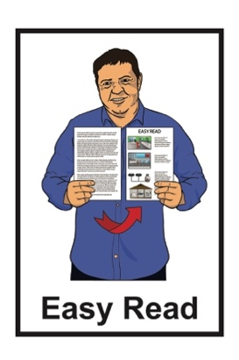

Have your say:

Changing the Total Mobility scheme
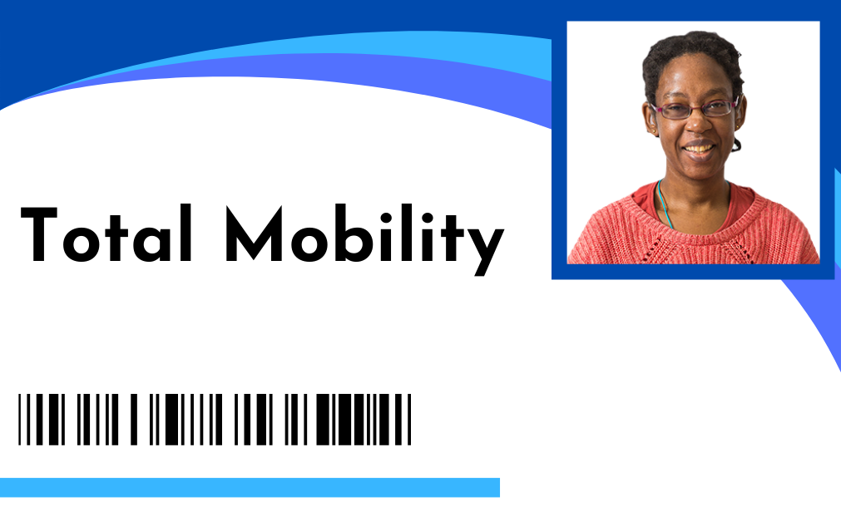
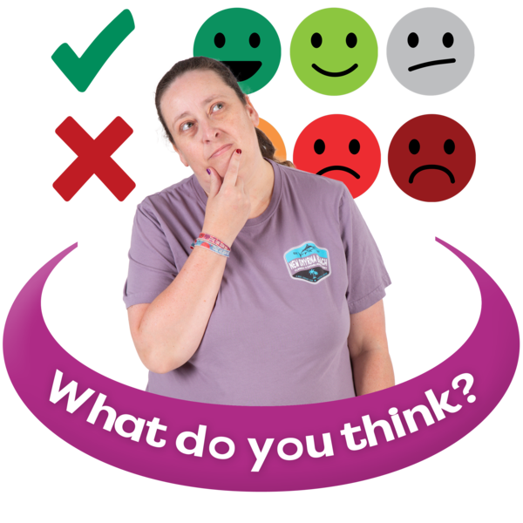

Published: December 2025

About this Easy Read


This Easy Read is from the Ministry of Transport Te Manatū Waka.

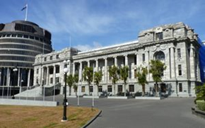
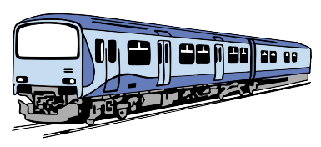
The Ministry of Transport Te Manatū Waka is the part of the Government in charge of the Aotearoa New Zealand transport system.


In this document the Ministry of Transport Te Manatū Waka will be called the Ministry of Transport.

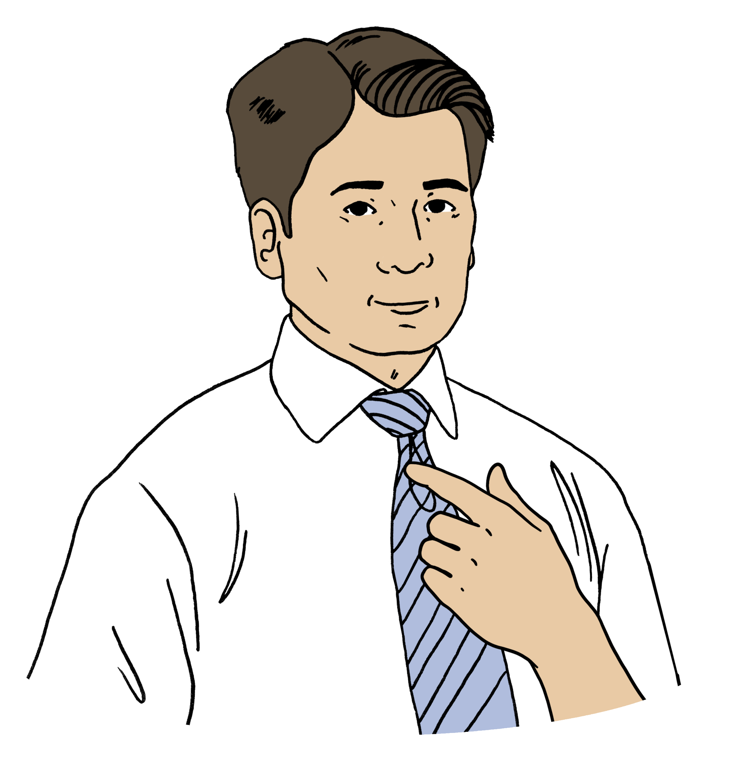
Where it says we / us this means
the Ministry of Transport.
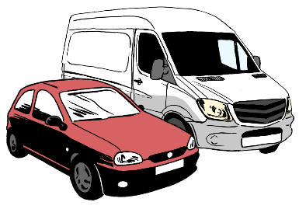
The transport system means anything that moves:
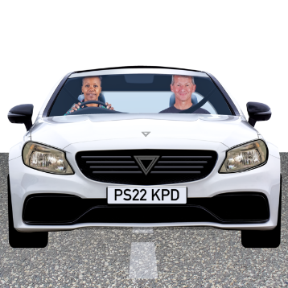
people around the country
things around the country.

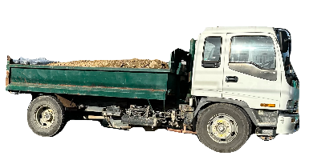
Some parts of the transport system are:
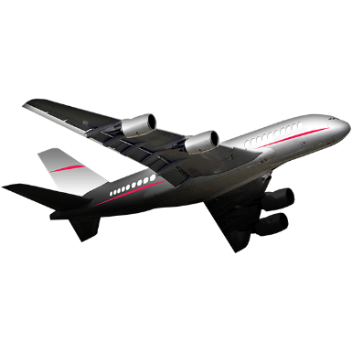
roads
trucks
trains
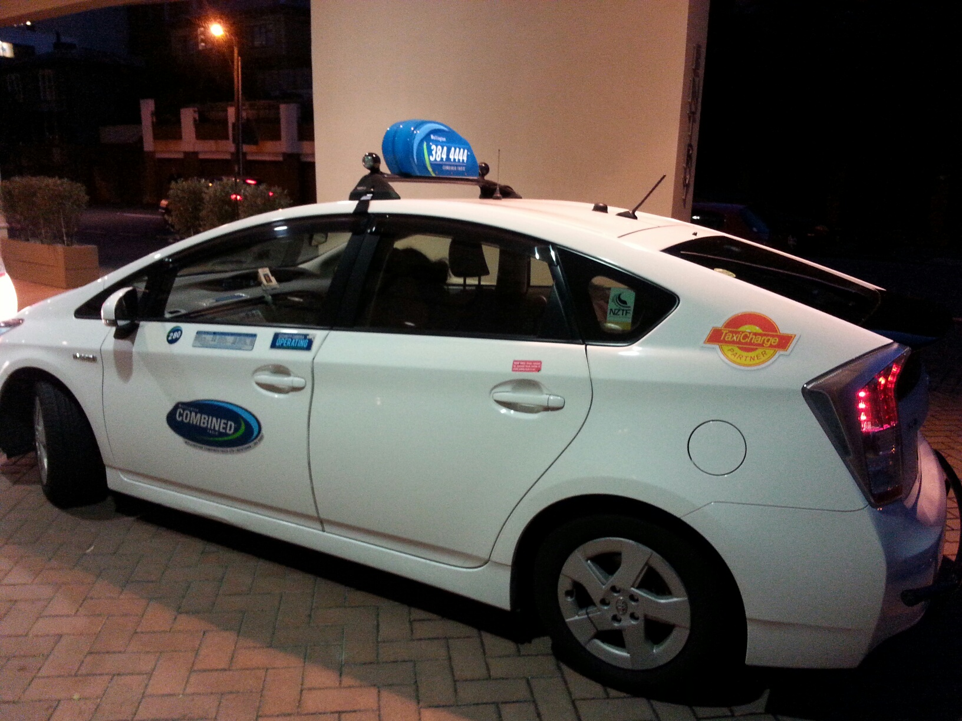
planes
boats.


We want to make Total Mobility stronger for:
users
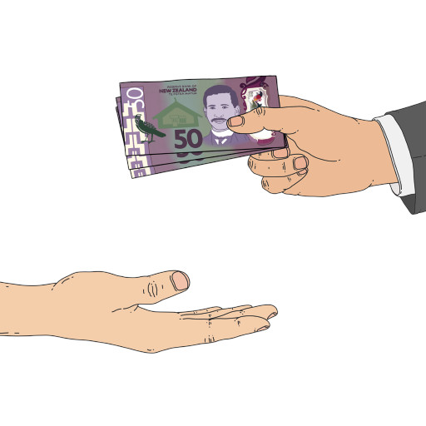
funders / people who give it money to run.

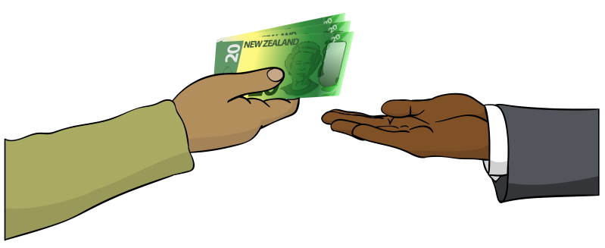
Total Mobility is a scheme that
supports disabled people to move around by paying part of the cost of taxi trips.

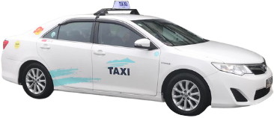
Disabled people can use Total Mobility if they cannot use public transport on their own.

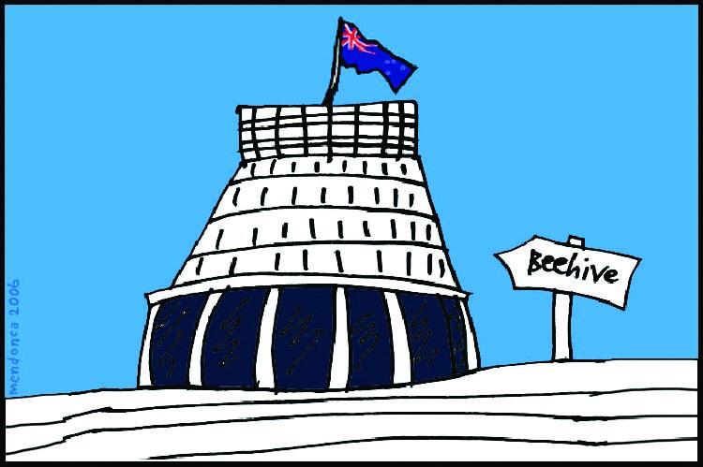
Some of the money for the Total Mobility scheme comes from:
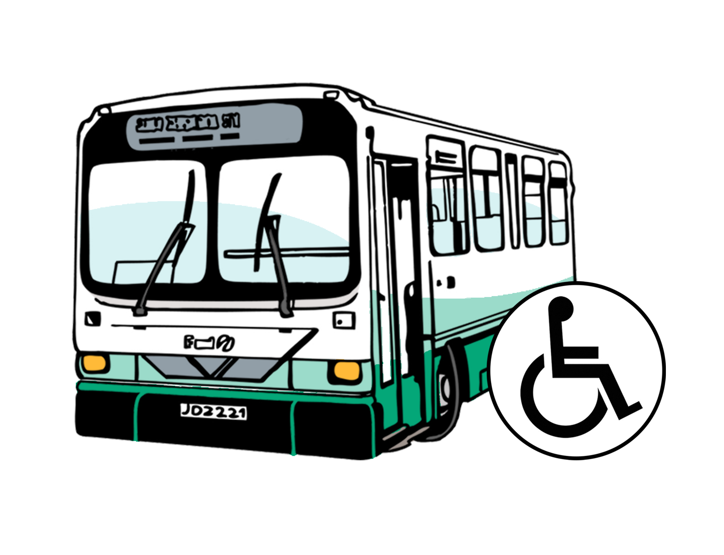
central government which
means the government for all
of Aotearoa New Zealand
- local government like public transport authorities.

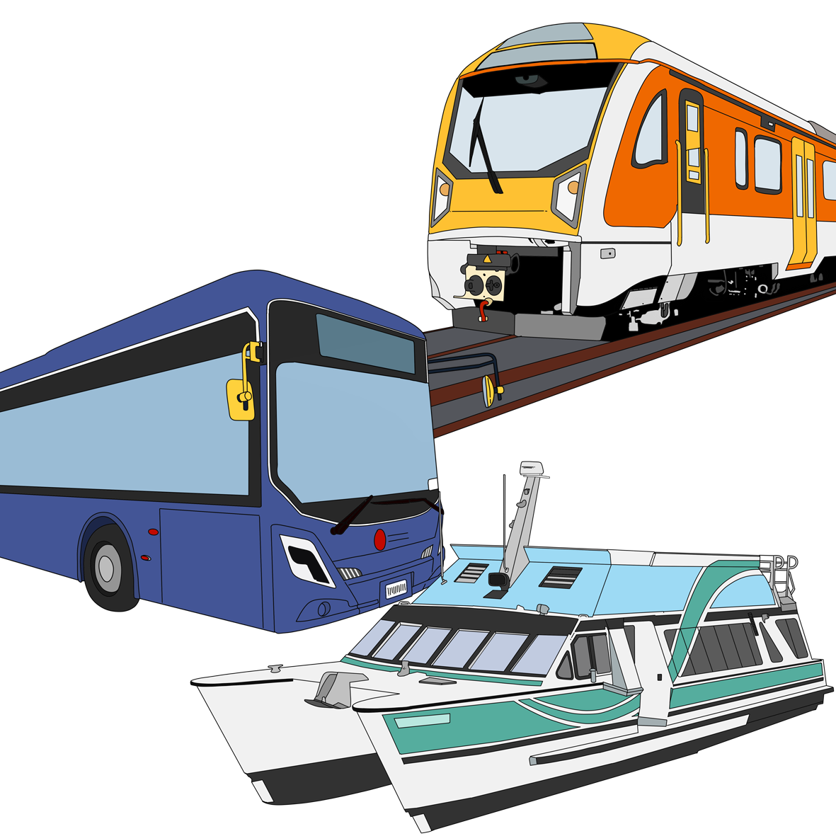
Public transport means:
buses
trains
ferries.

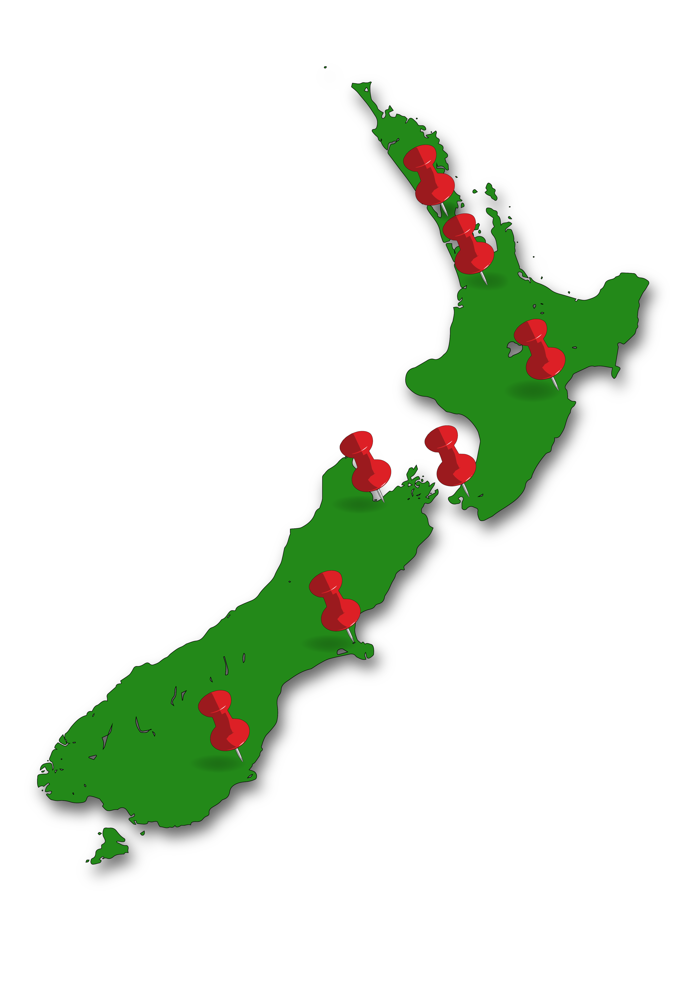
Public transport authorities are in charge of public transport in their
part of the Aotearoa New Zealand.


For example:
Auckland Transport is the public transport authority in Auckland
Greater Wellington Regional Council is the public transport authority in Wellington.

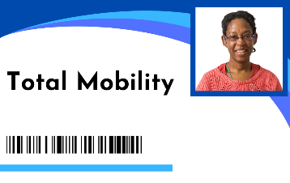
This Easy Read is the feedback form for the 6 proposals that are being talked about for Total Mobility.

Feedback means saying what you think about something.


Here a proposal means a:
kind of idea
thing that might be good to do.

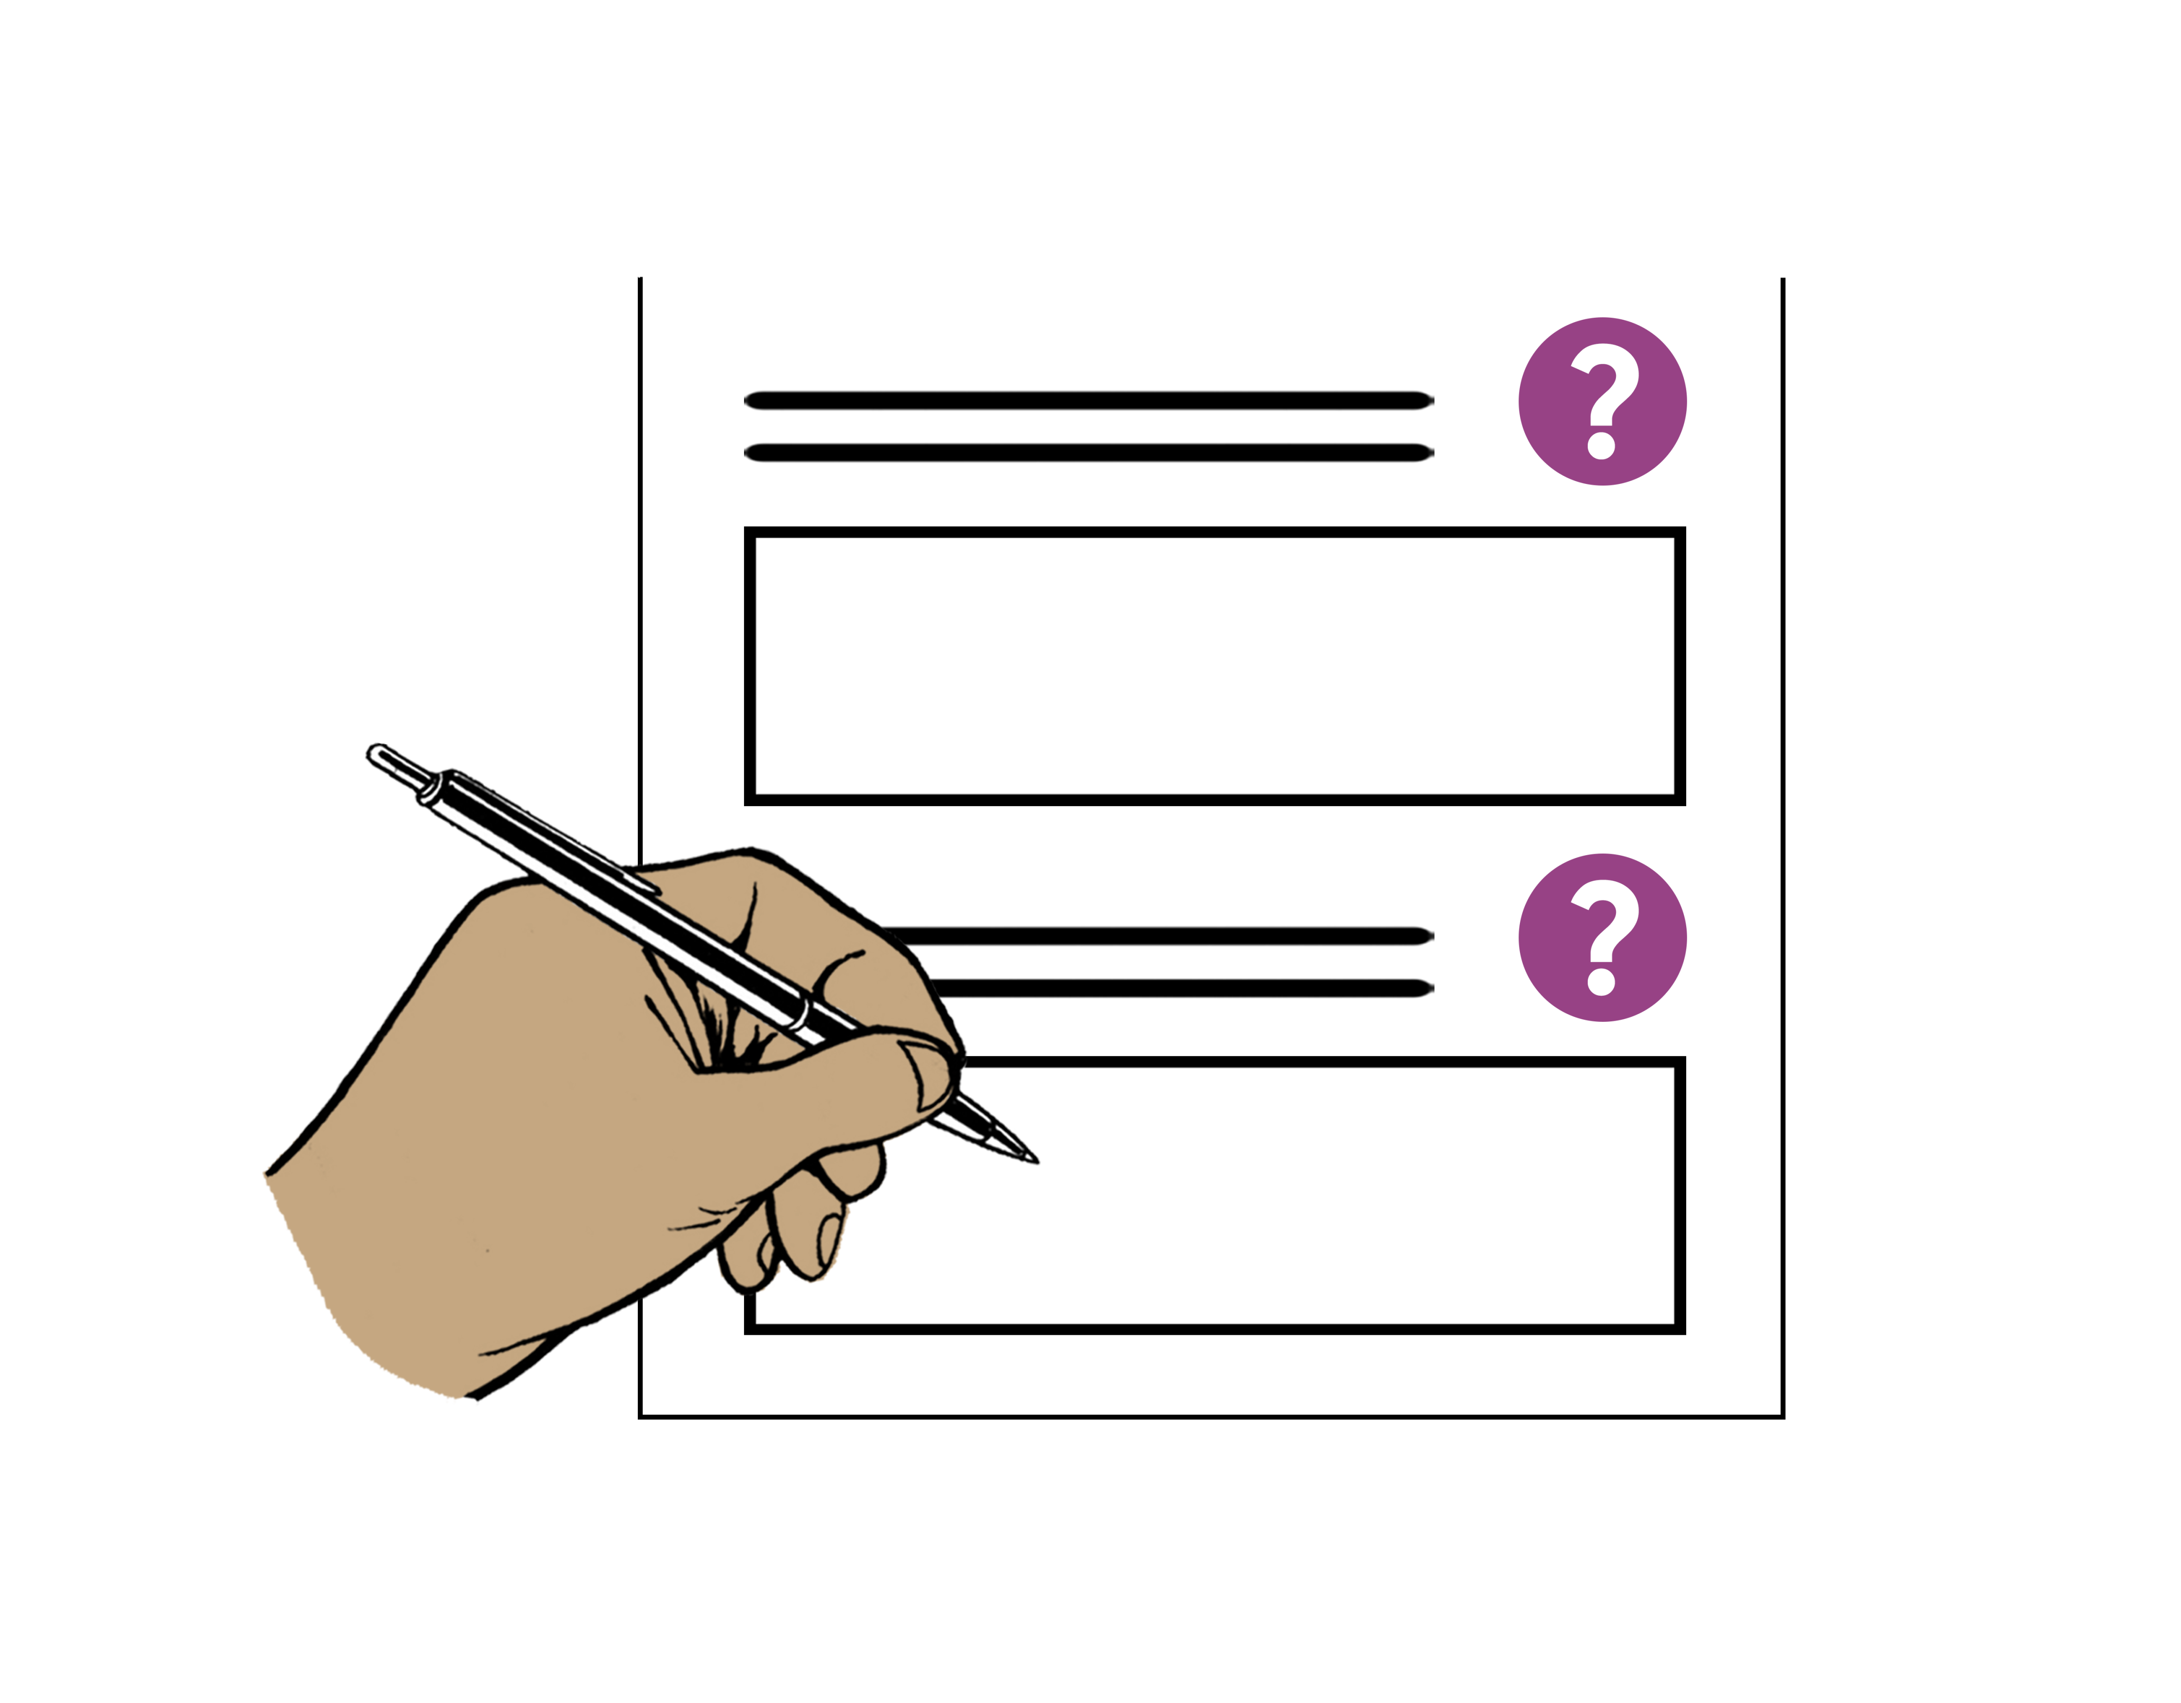
You can answer as many questions as you like in this feedback form.


When you have finished filling out this feedback form please send it back to us.

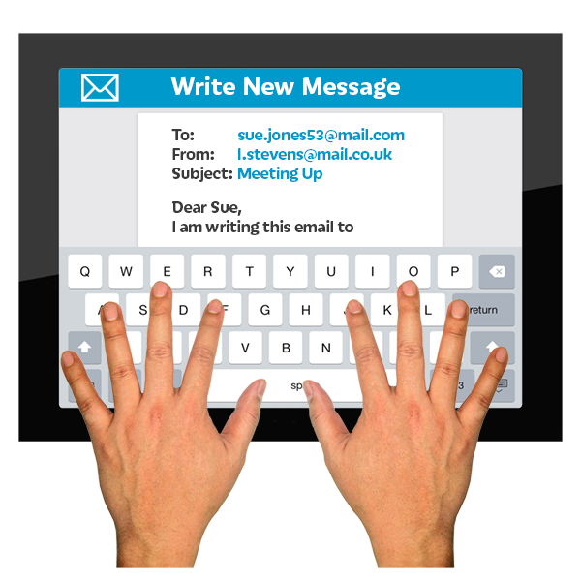
You can send it by:
email:

TotalMobilityReview@transport.govt.nz
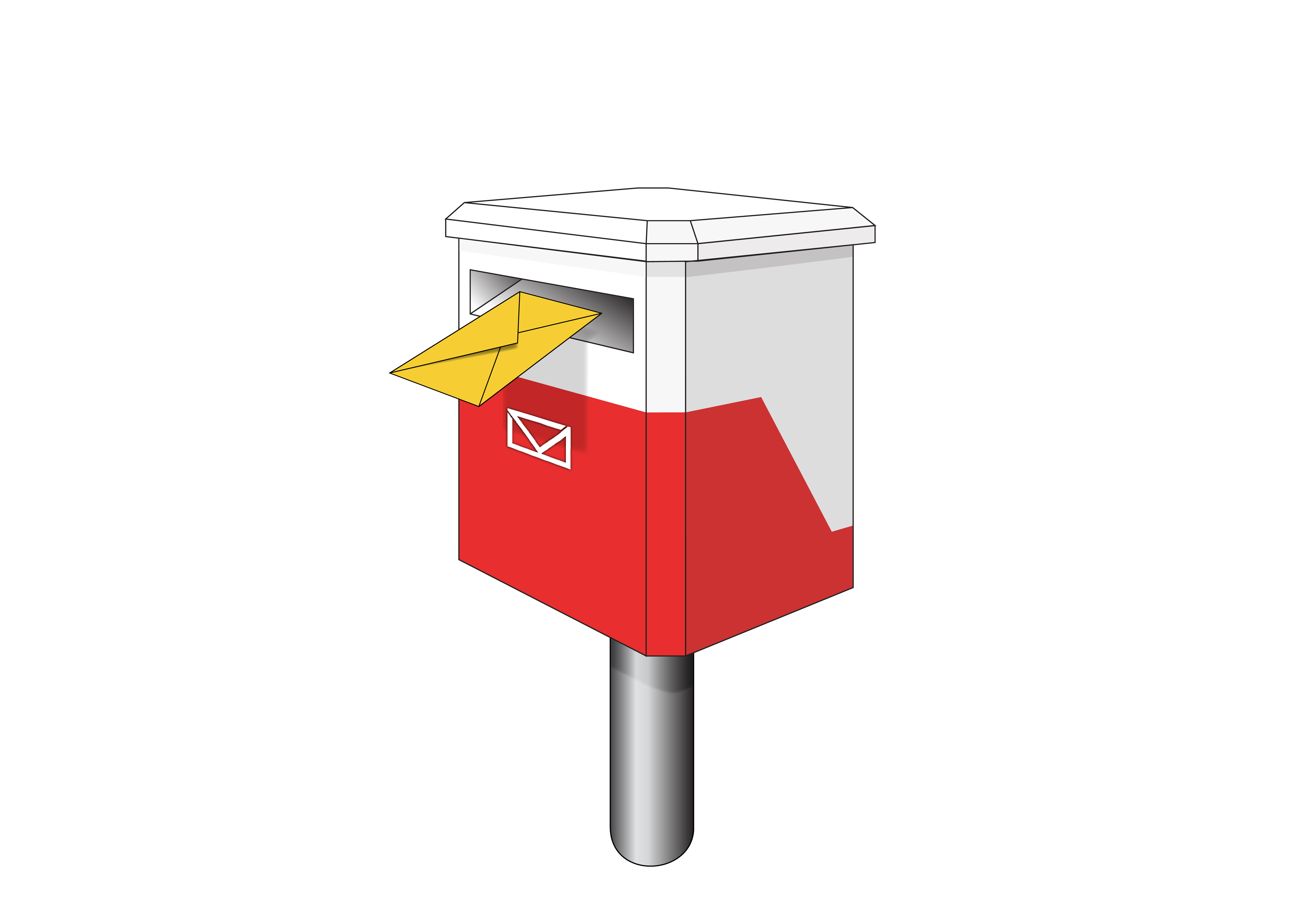
post:

Total Mobility Consultation
Ministry of Transport
PO Box 3175
Wellington 6140

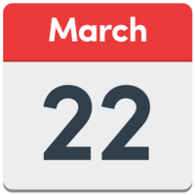
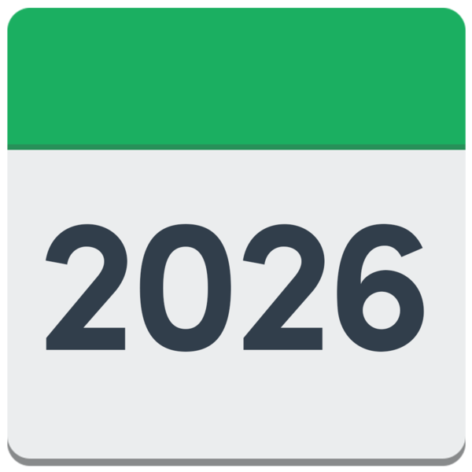
Send us your feedback by
22 March 2026.

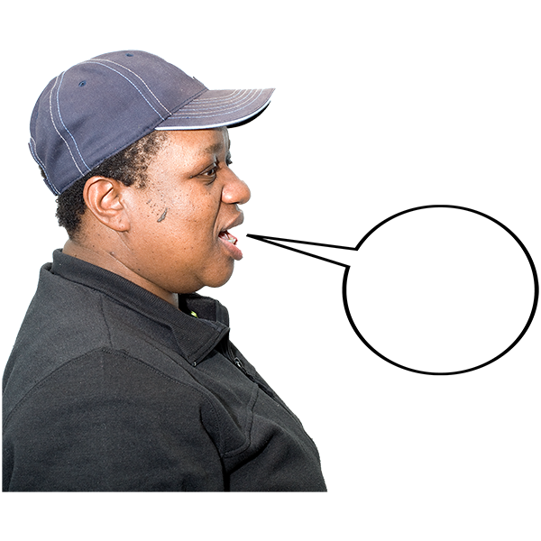
This document includes a quote which is words someone has said.

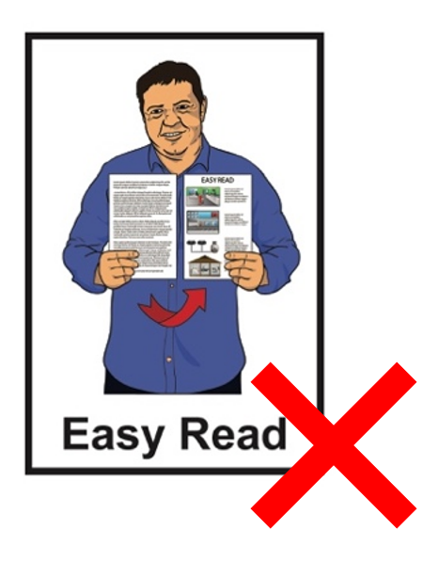
The quote is:
not in Easy Read
in a green box.

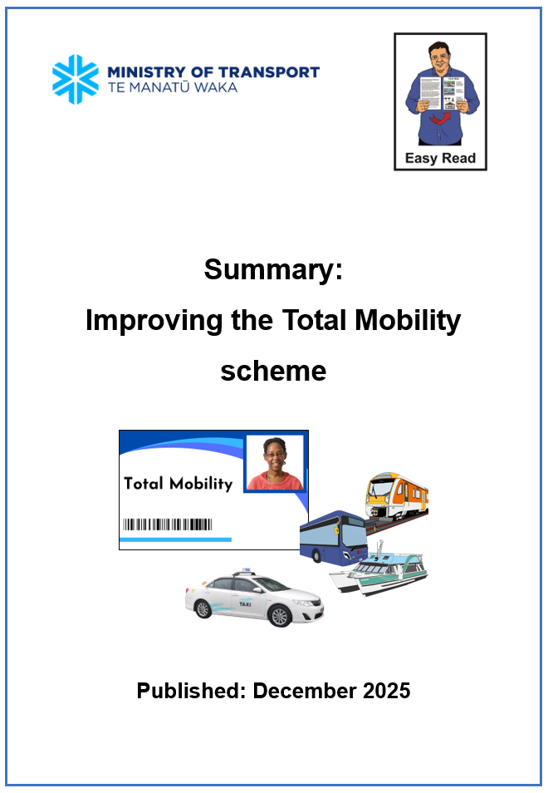
For information about the proposals you can read the Easy Read Summary: Improving the Total Mobility scheme:

https://tinyurl.com/36jzta2j

Information about you


Tick the box that is right for you.

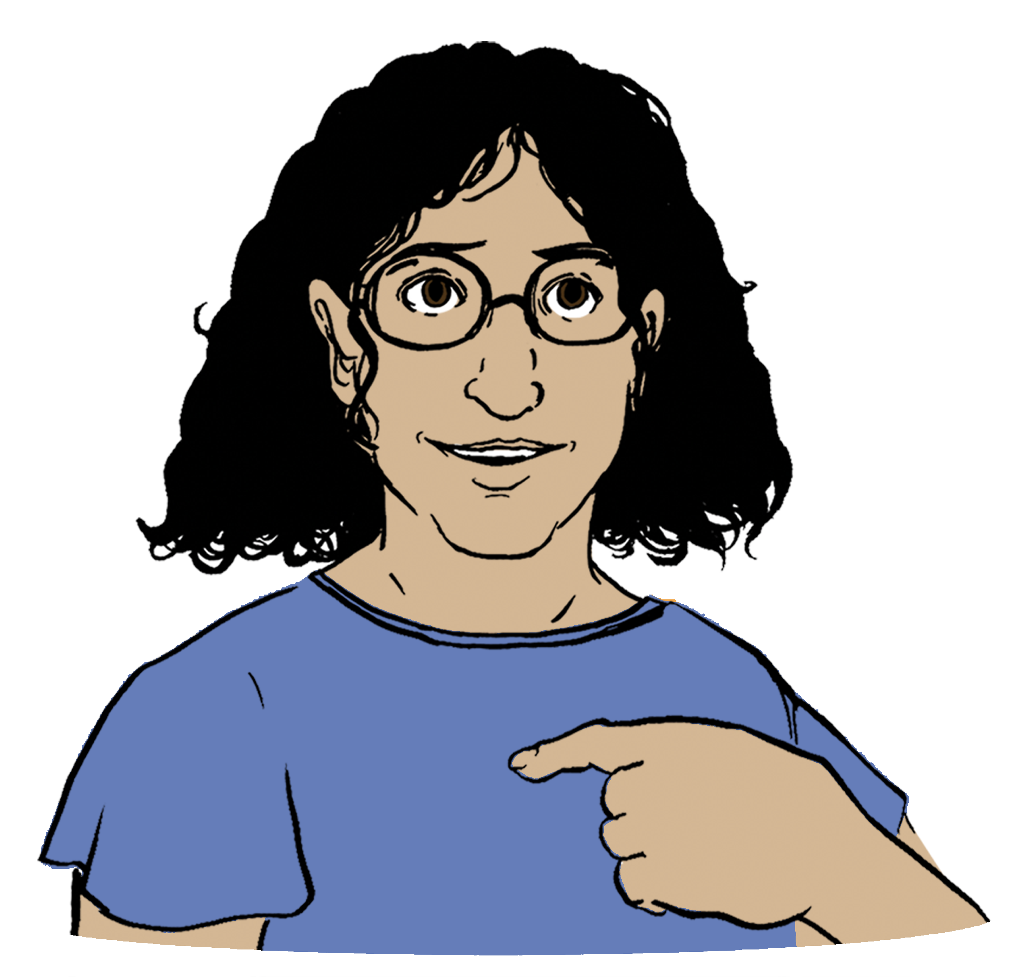
Are you giving feedback for:

yourself

someone else

a group of people

an organisation?

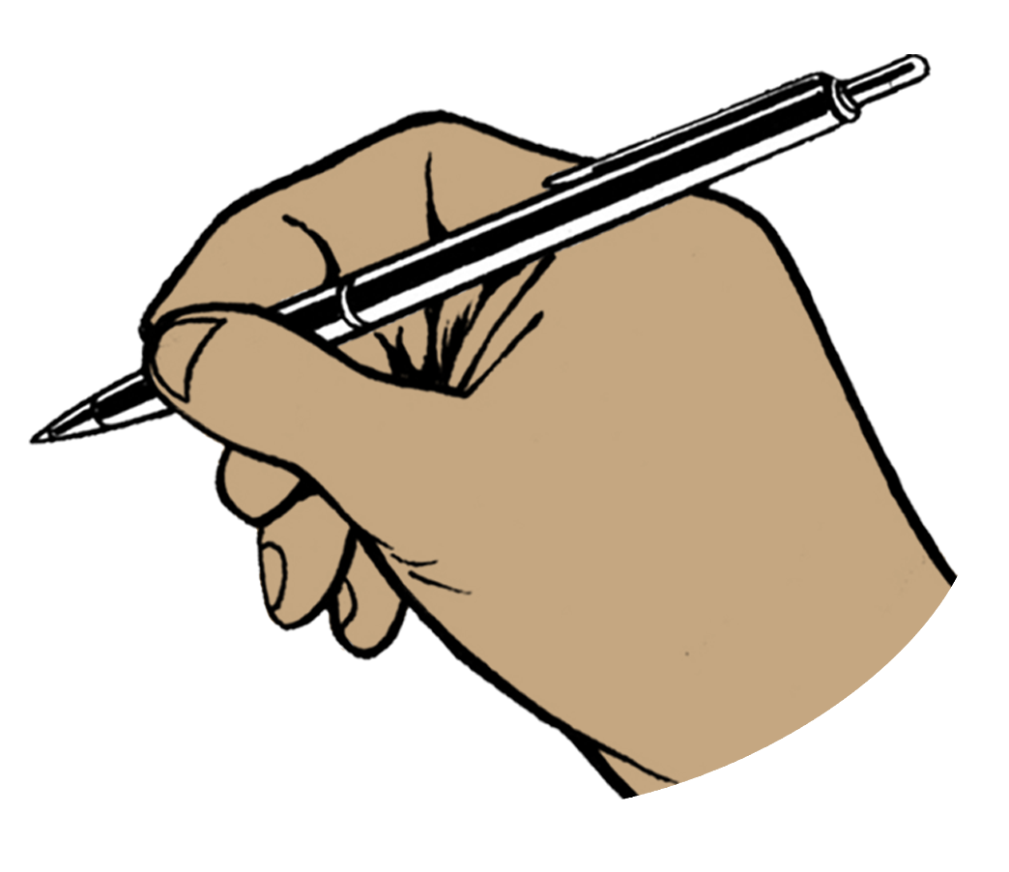
If you are giving feedback for a group or organisation please put the name in the box below.

Tick the box that is right for you.

What is your connection to Total Mobility?
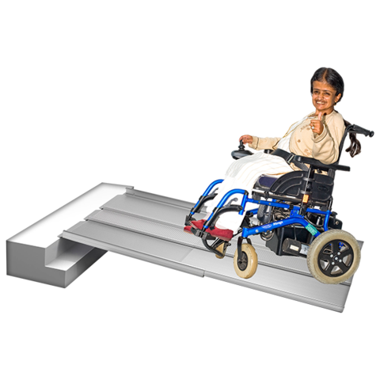
I use Total Mobility

I support someone who uses Total Mobility

I am a Total Mobility service provider

I am from a local council


I am from a community group or organisation

something else – put what this is in the box below:

Tick the boxes that are right for you.

Are you a disabled person?

Yes

No.

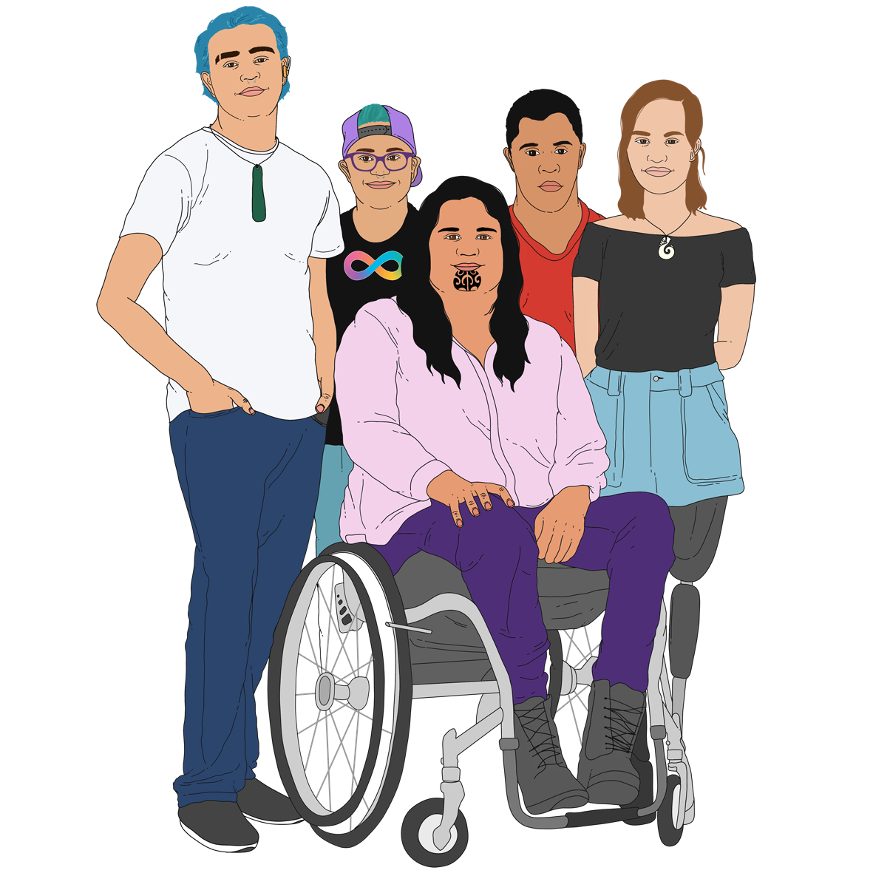
Are you tāngata whaikaha Māori / a Māori disabled person?

Yes

No.

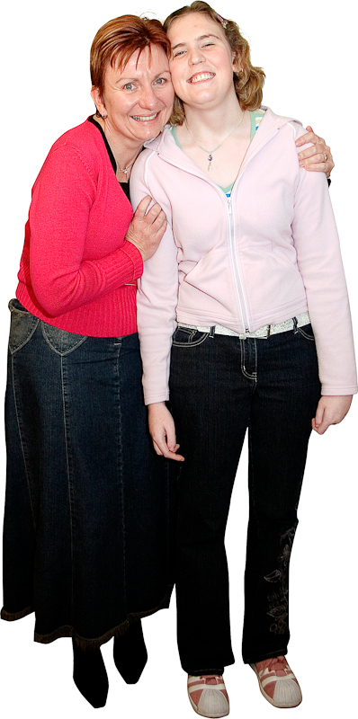
Are you a carer or family member of a disabled person?

Yes

No.

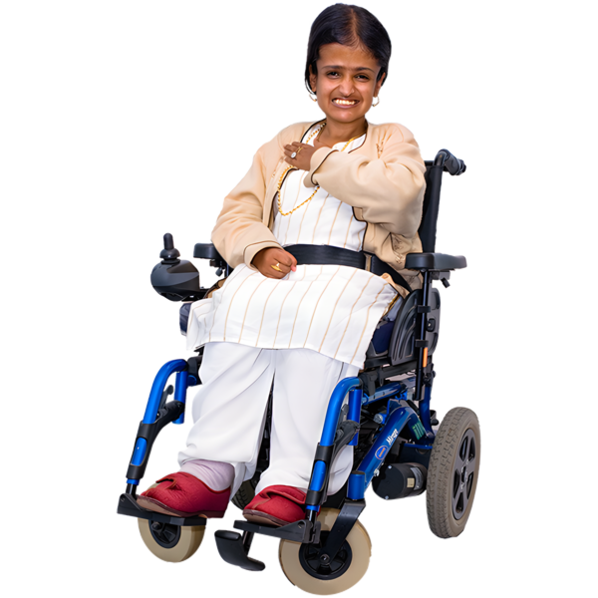
What type of impairment do you live with?

physical like something to do with your body
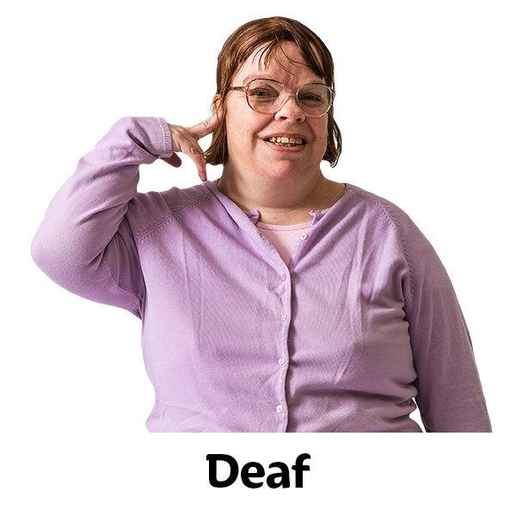
hearing like being deaf

vision like being blind

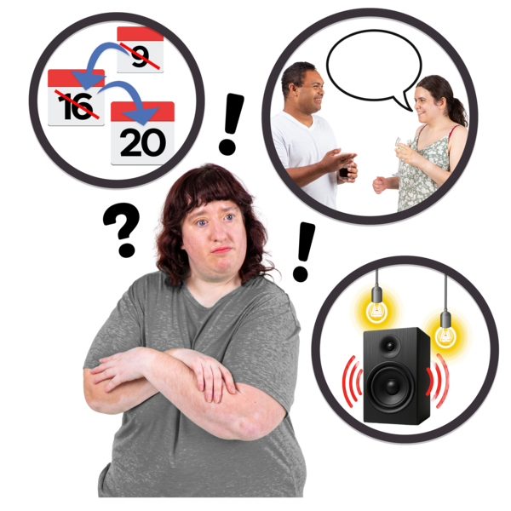
speech like finding it hard to talk

something to do with your brain like:
learning
cognitive
neurological.

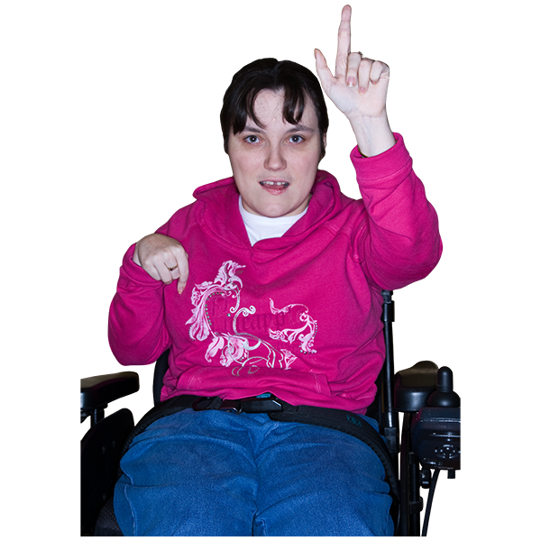
How old are you?

under 15 years

15 to 29 years
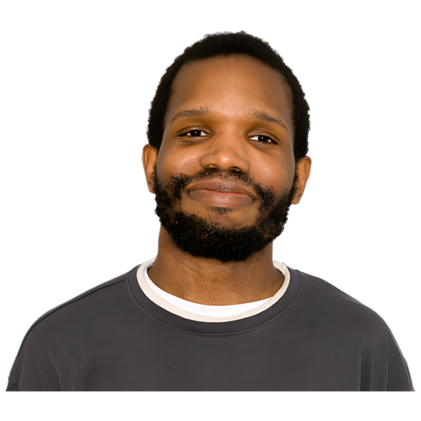
30 to 44 years

45 to 64 years
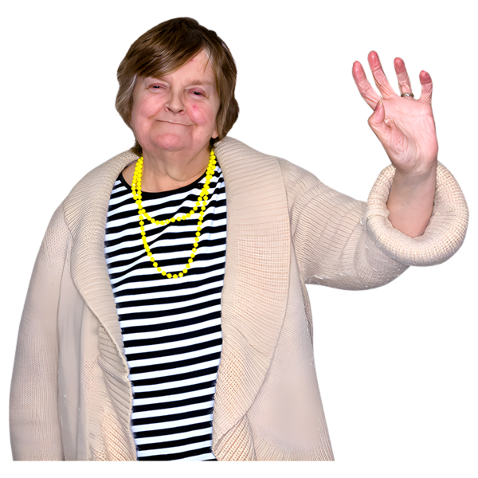
65 to 74 years

75 years or older.

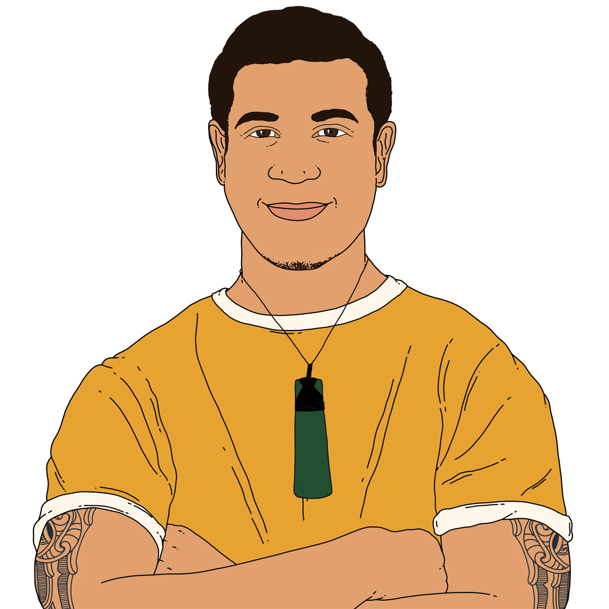
What is your gender?

male

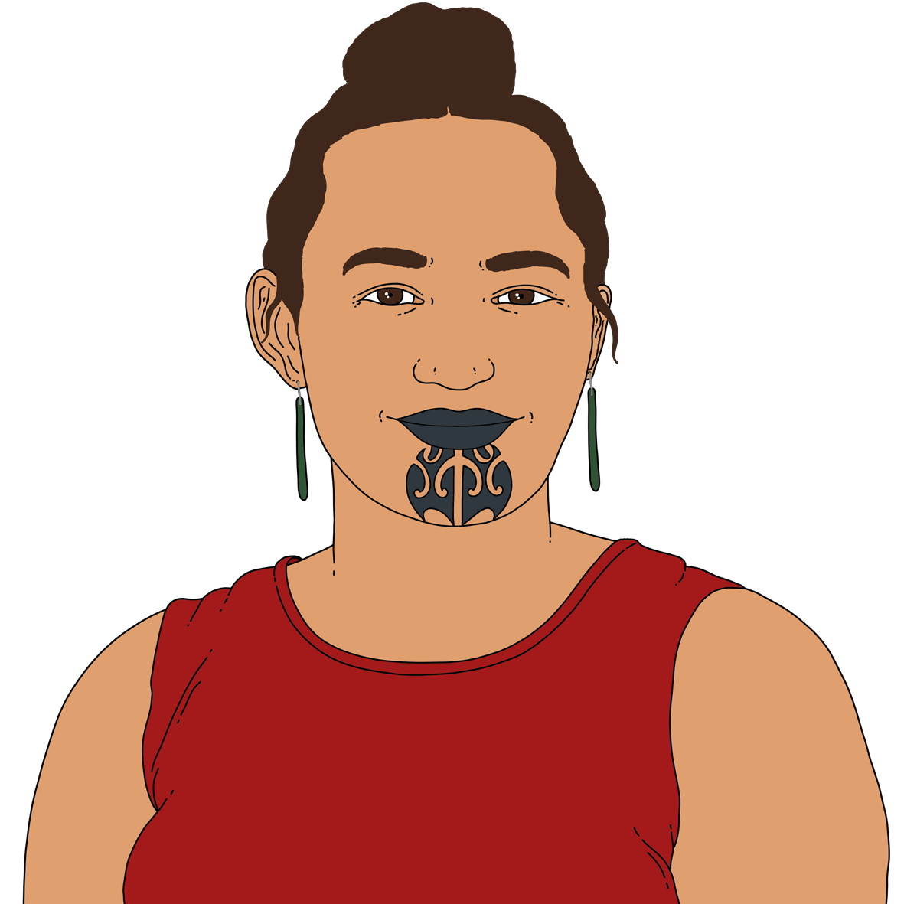
female

another gender

I do not want to say.

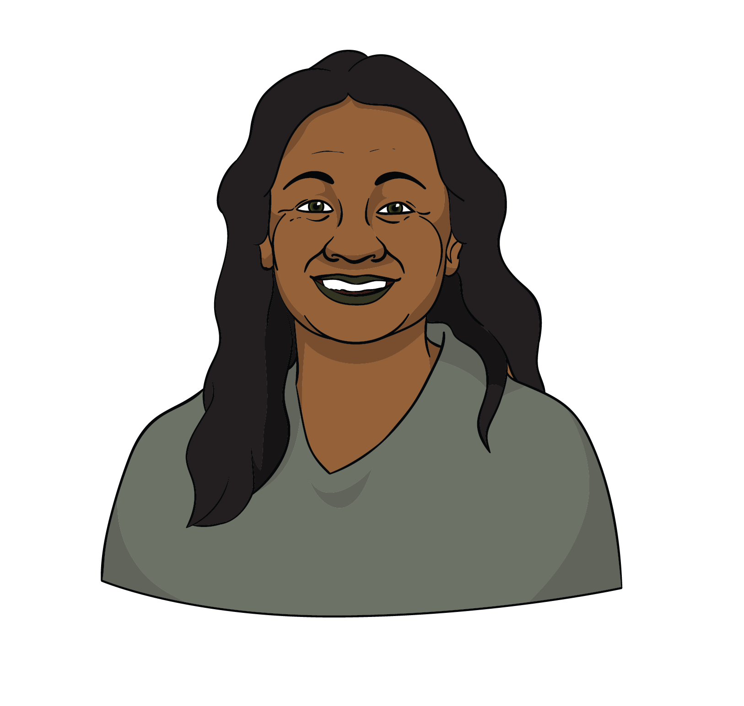
What ethnic group do you belong to?

New Zealand European

Māori
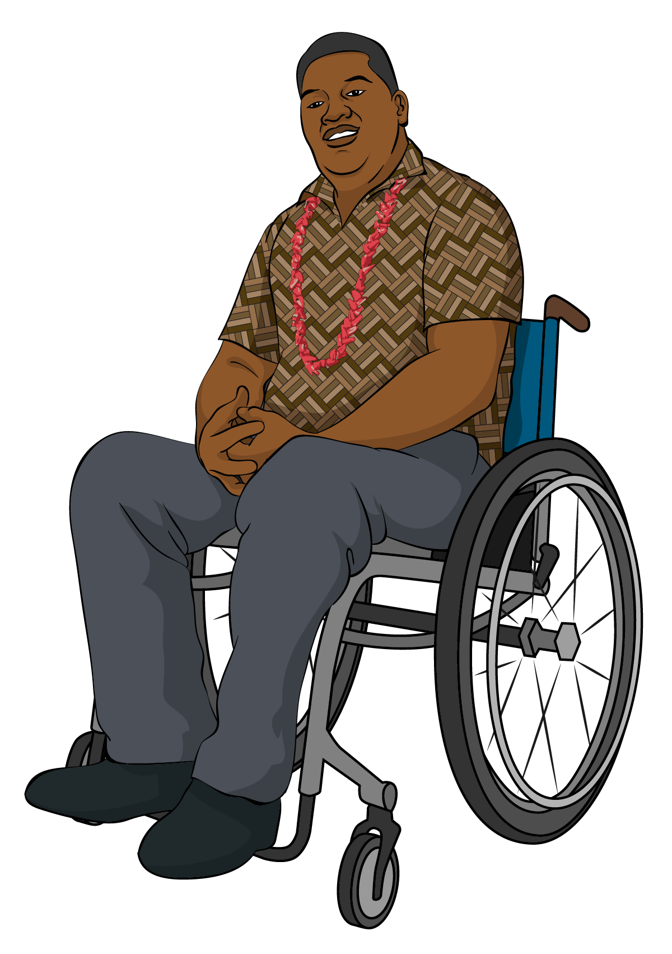
Samoan

Cook Islands Māori

Tongan


Niuean

Chinese

Indian
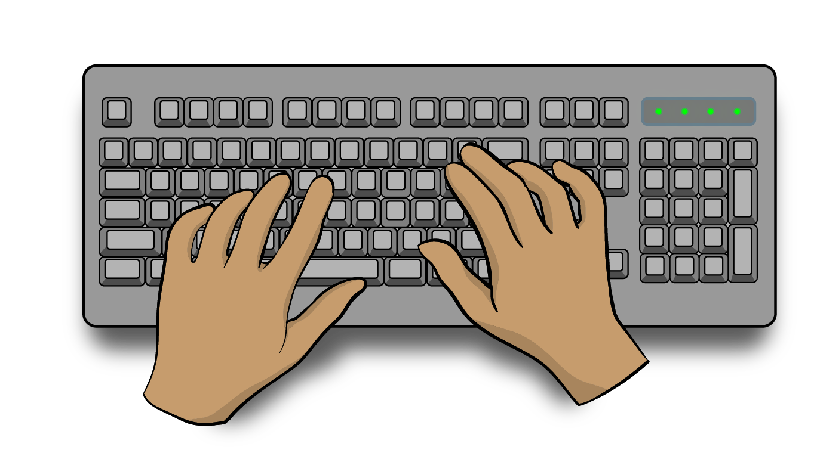
something else – put what this is in the box below:

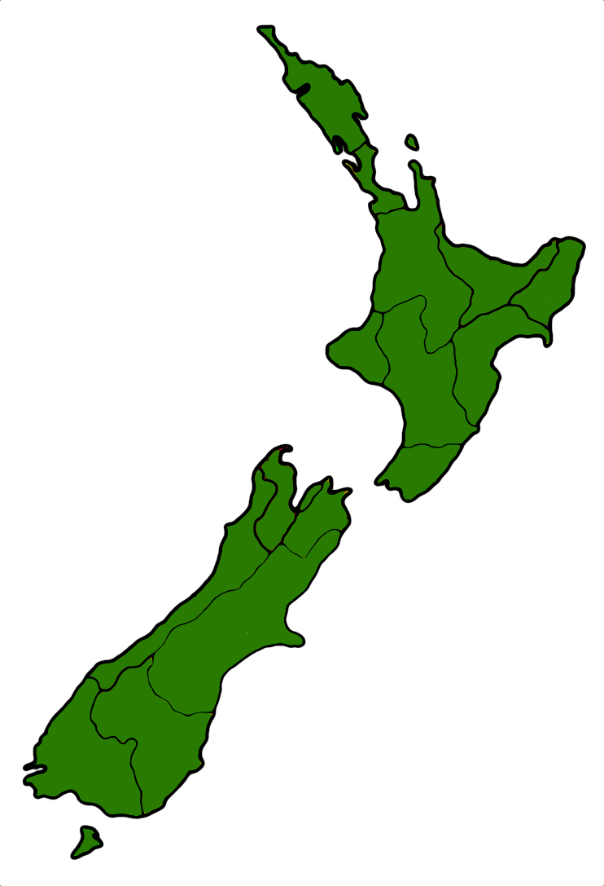
What part of the country do you live in most of the time?

Northland

Auckland

Waikato

Bay of Plenty

Gisborne

Hawke’s Bay

Taranaki

Manawatu – Whanganui

Wellington

Nelson

West Coast

Canterbury

Otago

Southland.

Questions for feedback

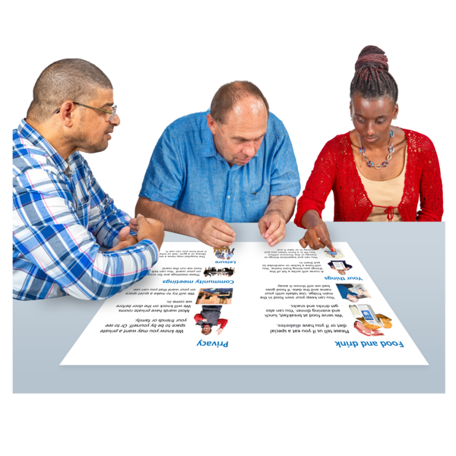

Proposal 1: Make a clear purpose statement for Total Mobility.


A purpose statement talks about what an organisation:
does
wants.

The change to the purpose statement that has been suggested is:

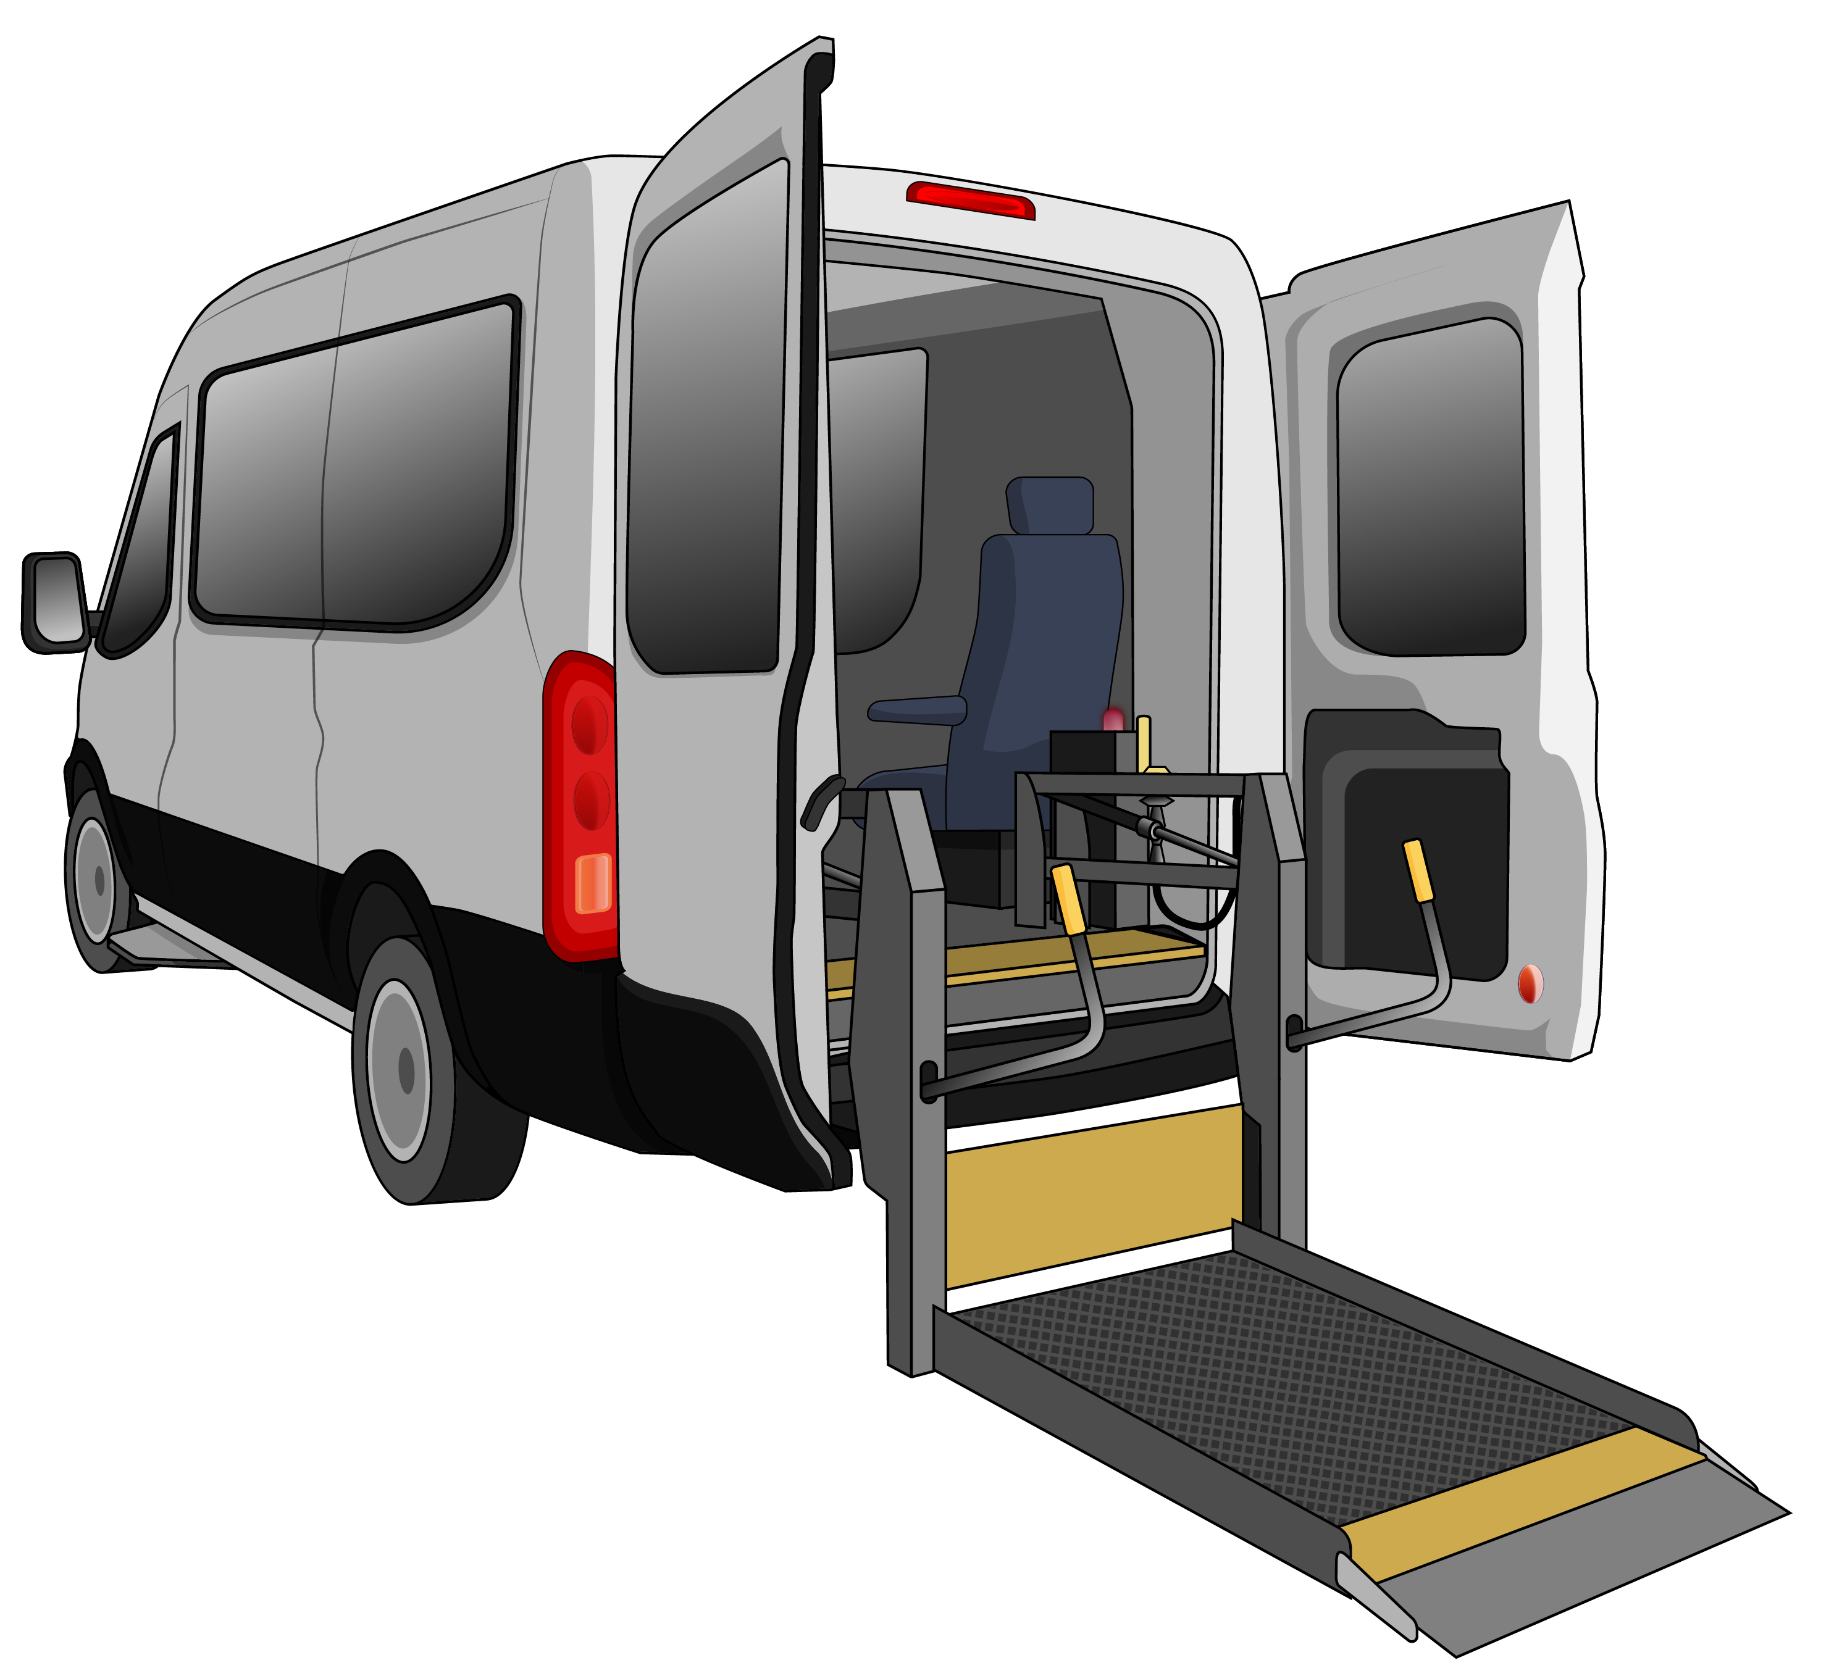
“To provide subsidised mobility services to disabled people who are unable to access public transport because of an impairment, to
support them to live their lives.”

Tick the box that is right for you.

Do you support the suggested new purpose statement?

Yes

No

I do not know.

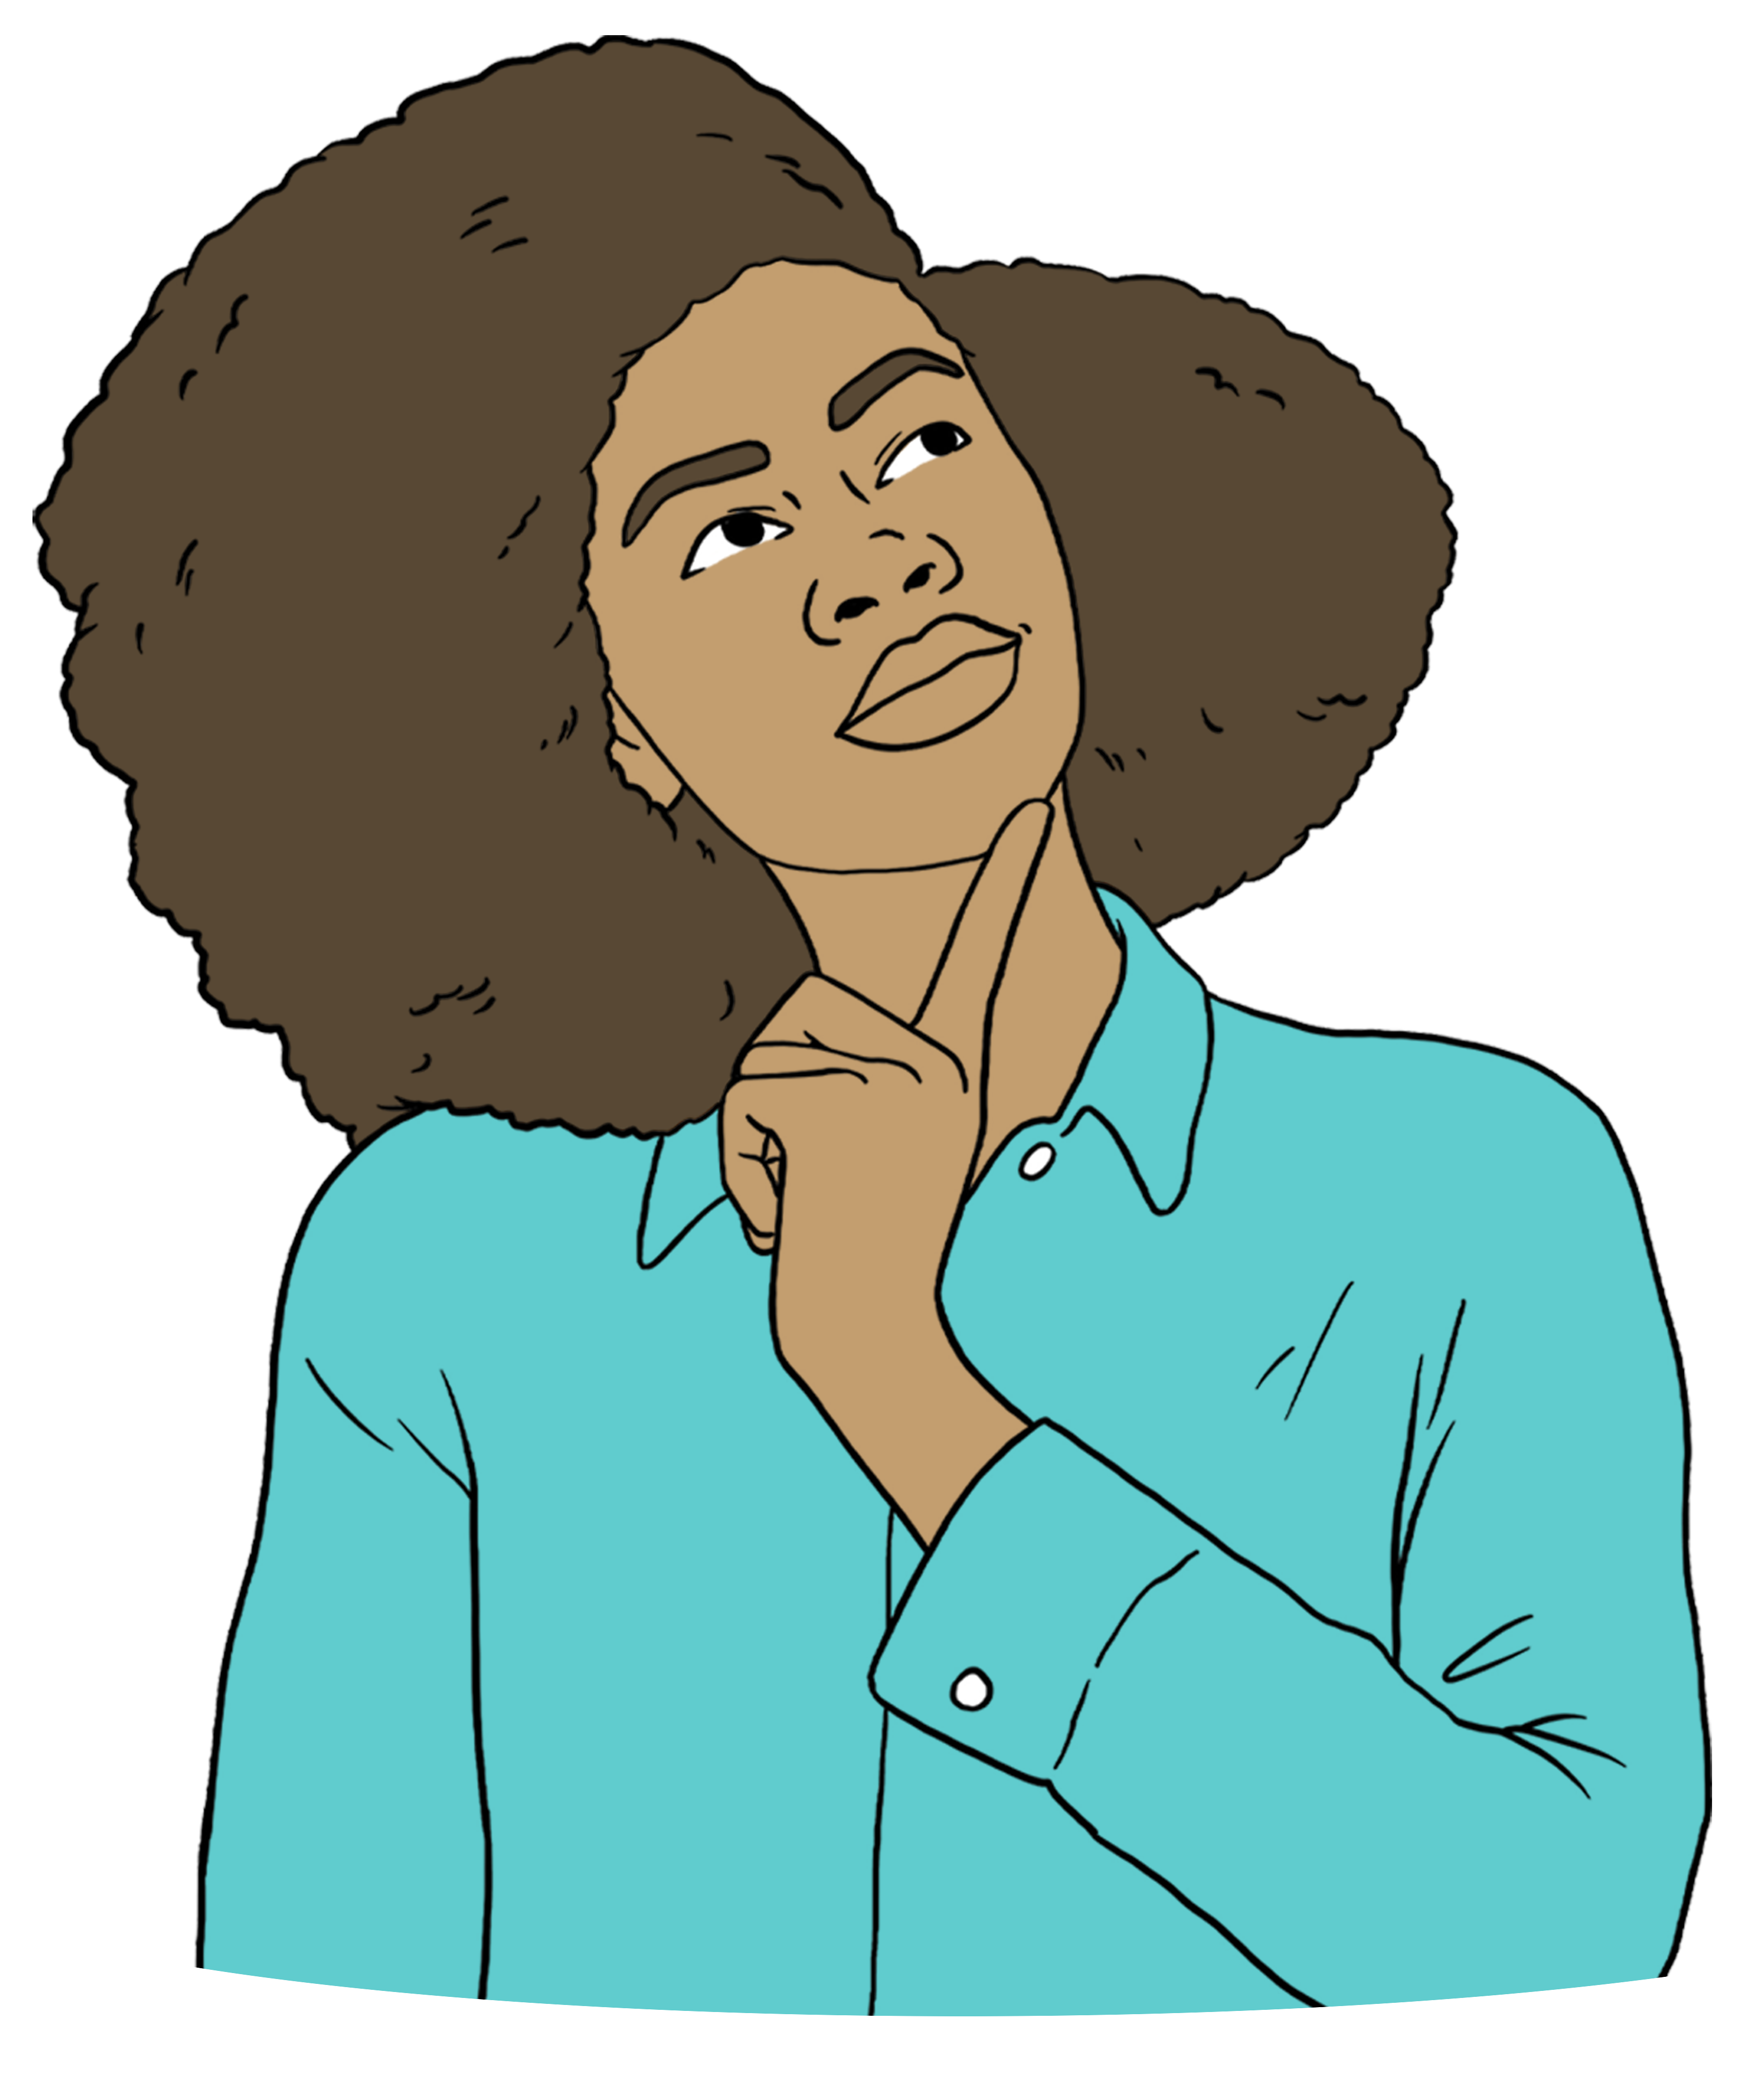
Is there anything you would change about the suggested new purpose statement?

Put your answer in the box below.

Proposal 2: Make changes to assessments.
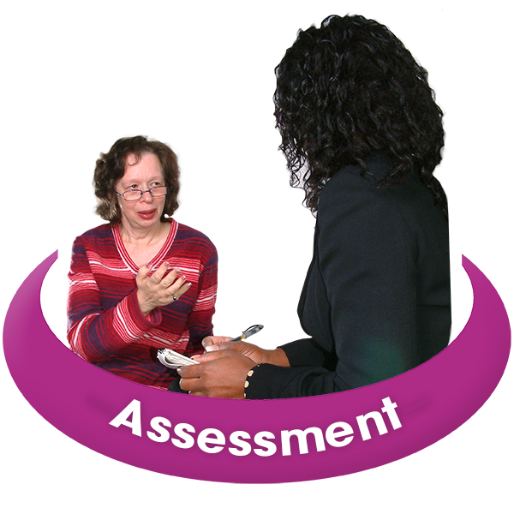
Here an assessment means talking about your disability to find out if you can use Total Mobility.

Tick the box that is right for you.


Do you think the Government should ask for documents that prove the disability a person has when they apply for Total Mobility?

Yes

No

I do not know.

Tick the box that is right for you.

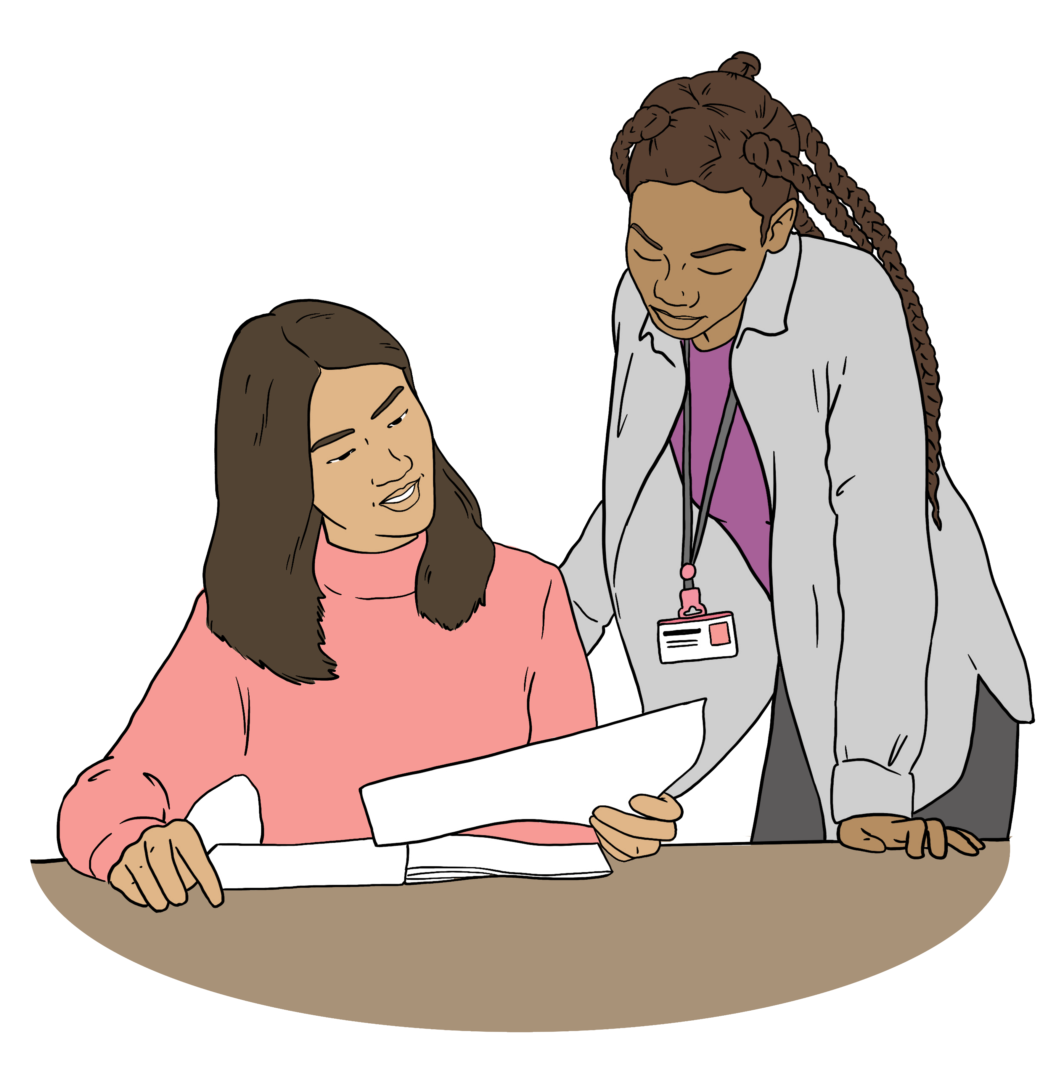
Do you think the Government should get people to do reassessments for Total Mobility?

Yes

No

I do not know.

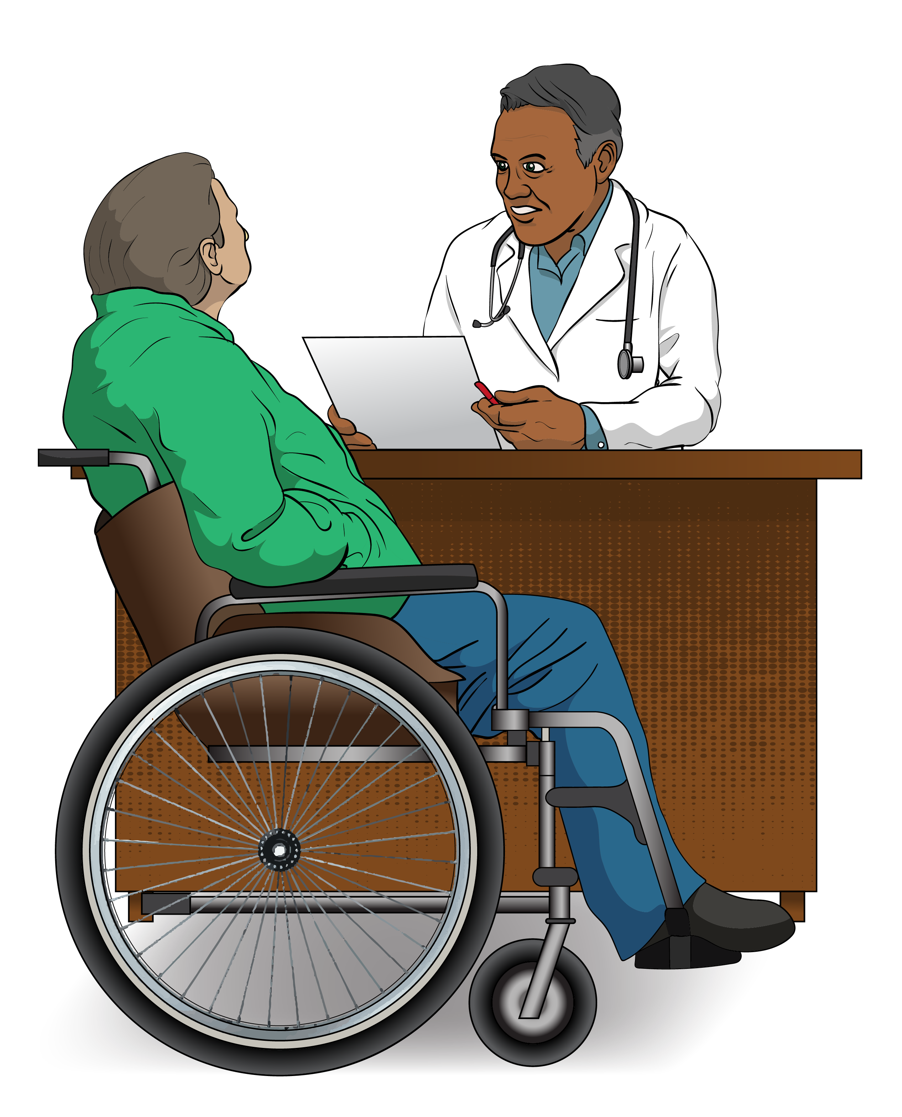
Here reassessment means doing an assessment again to:
make sure things are still correct
check if things might need to change.

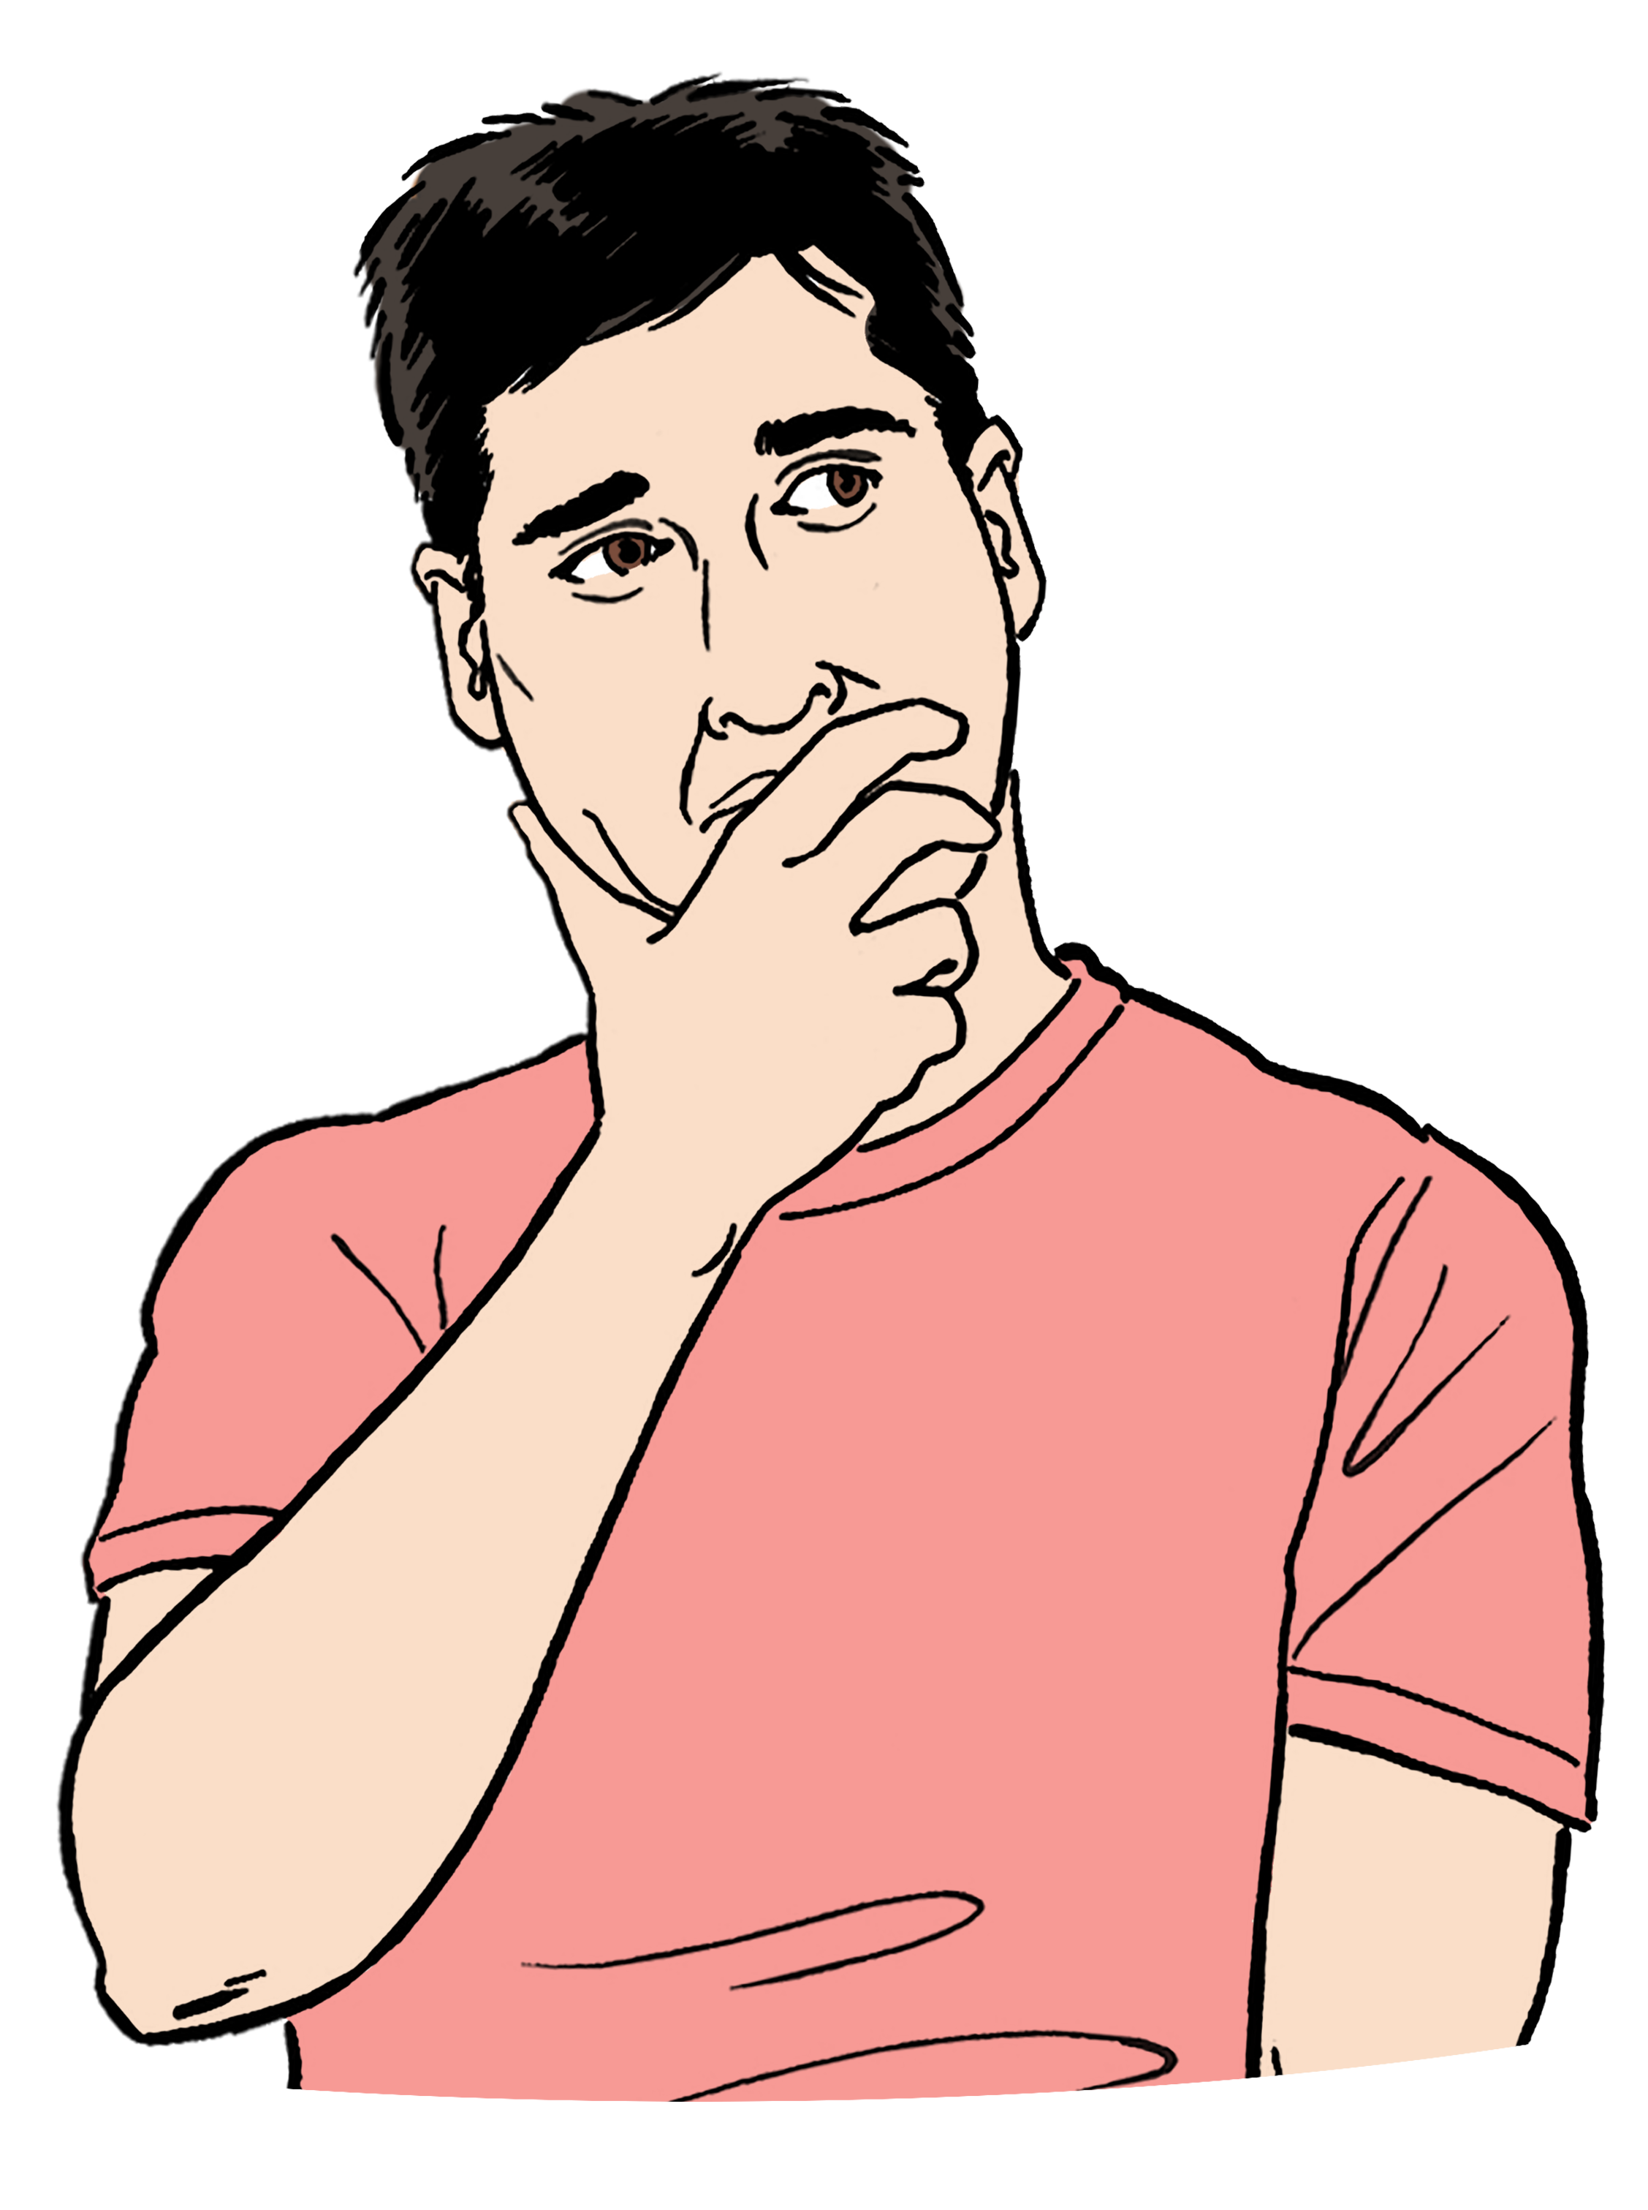
Is there anything else you would like to say about this proposal?

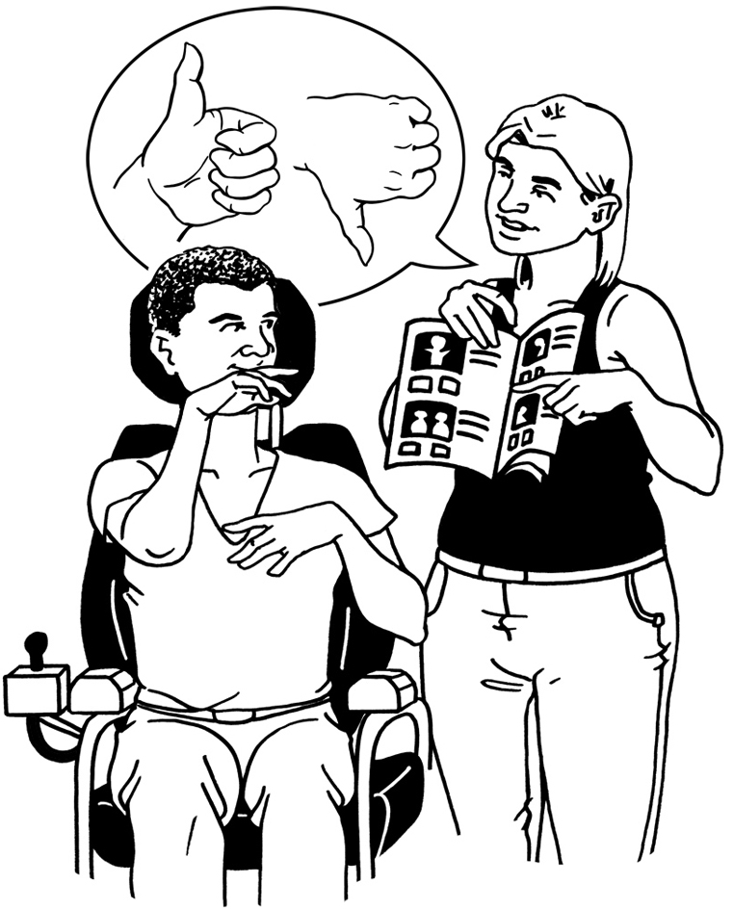
You might want to talk about:
the good things about the proposal
the bad things about the proposal
how often a reassessment could be done.

Put your answer in the box below.

Proposal 3: Limit the number of trips.
Tick the box that is right for you.

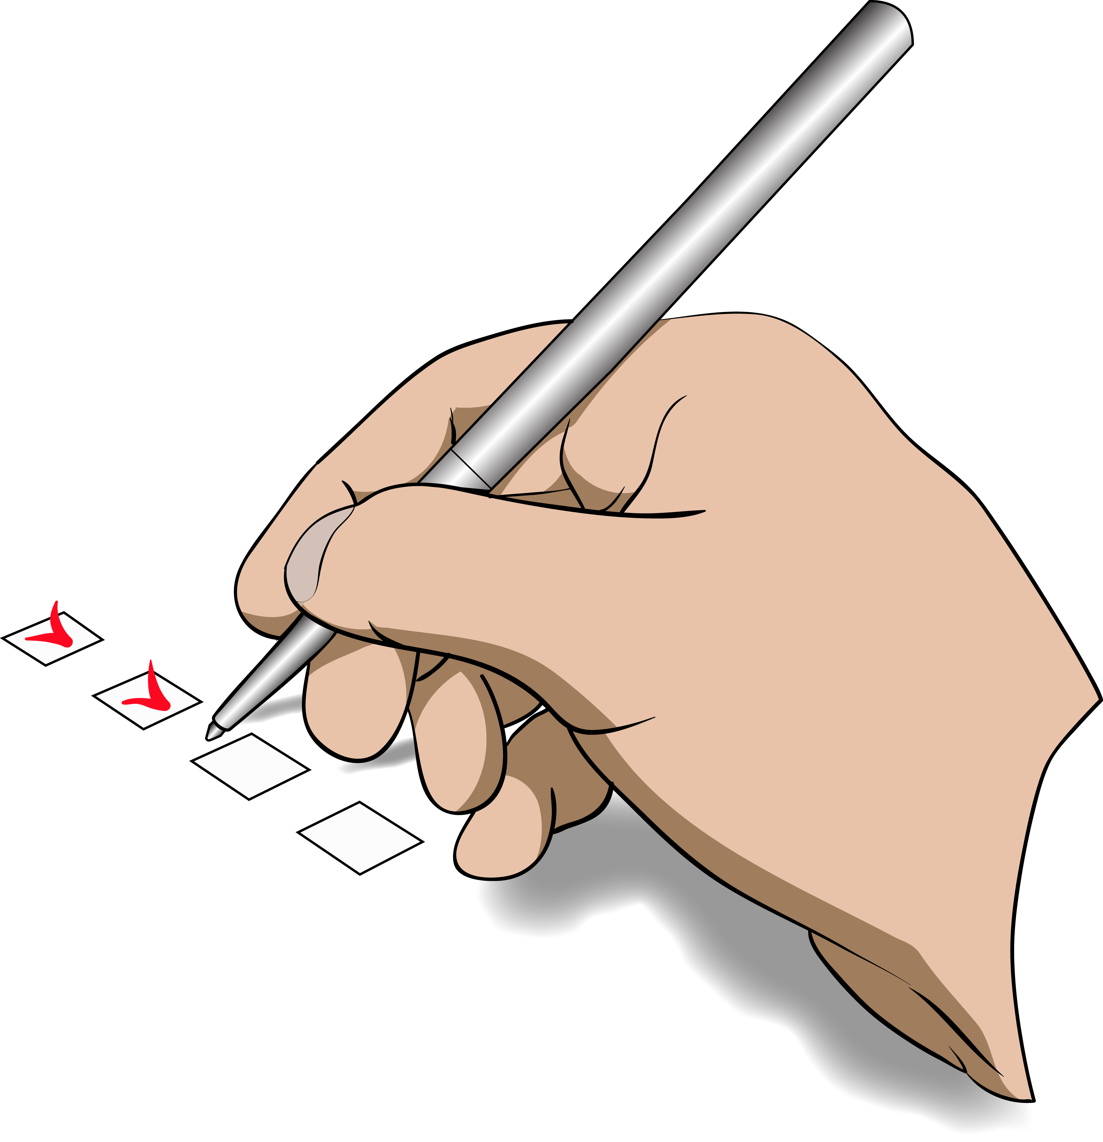
As a way to focus support where it is needed do you think the Government should limit / make a total number of trips a user can take?

Yes

No

I do not know.

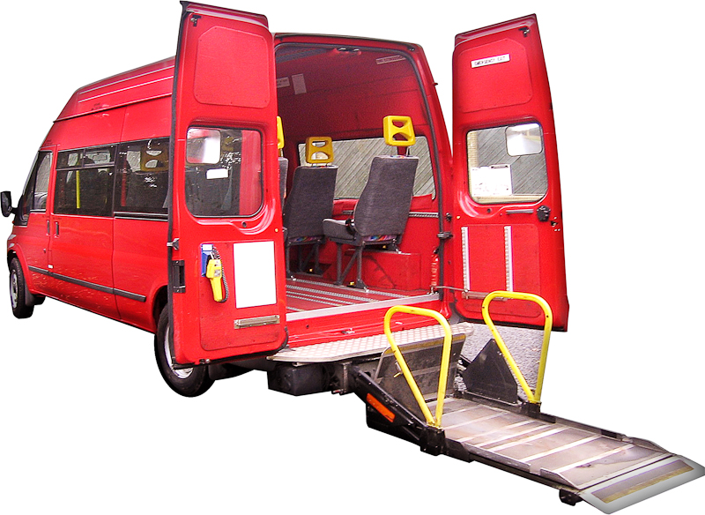
Which do you think the Government should choose if they did limit / make a total number of trips?

the same number of trips for everyone

a set number of trips to start with for everyone then more trips for people who need them.

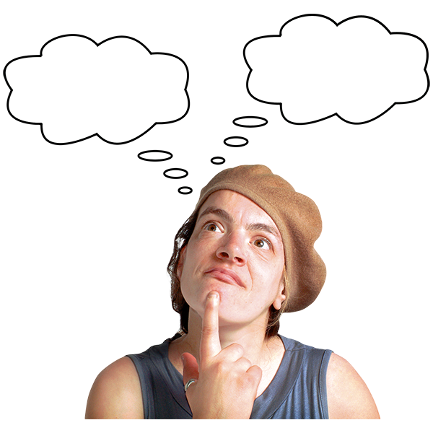
Is there anything else you would like to say about this proposal?


You might want to talk about:
the good things about the proposal
the bad things about the proposal.

Put your answer in the box below.

Proposal 4: Make more wheelchair accessible trips.
Tick the box that is right for you.

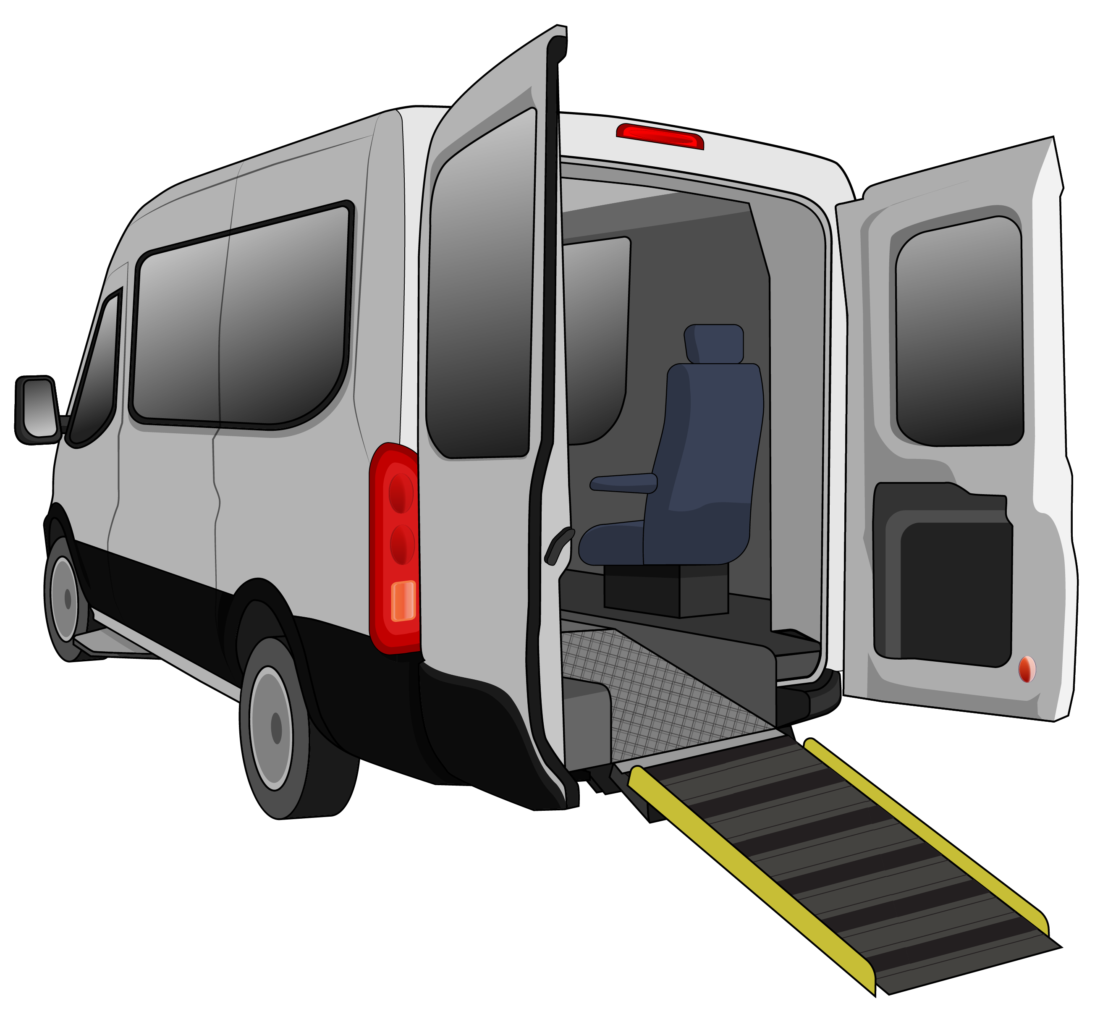
Do you think the Government should make more incentives for providers to have vehicles wheelchairs can go in?

Yes

No

I do not know.

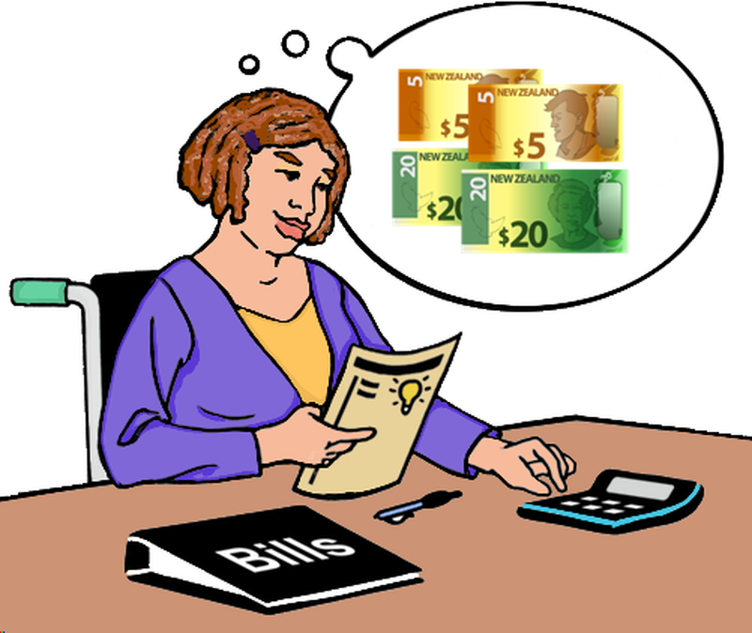
Here incentive means giving someone a reason to do something like money.


Is there anything else you would like to say about this proposal like how it could be done?

Put your answer in the box below.

Proposal 5: Let new providers join Total Mobility.
Tick the box that is right for you.

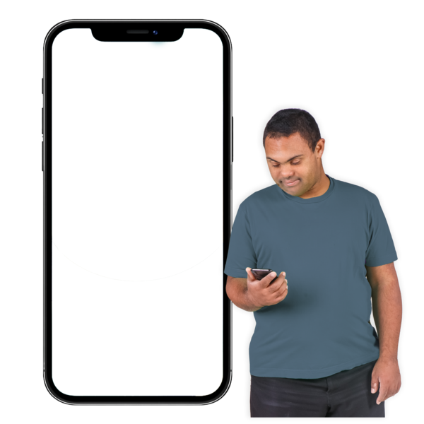
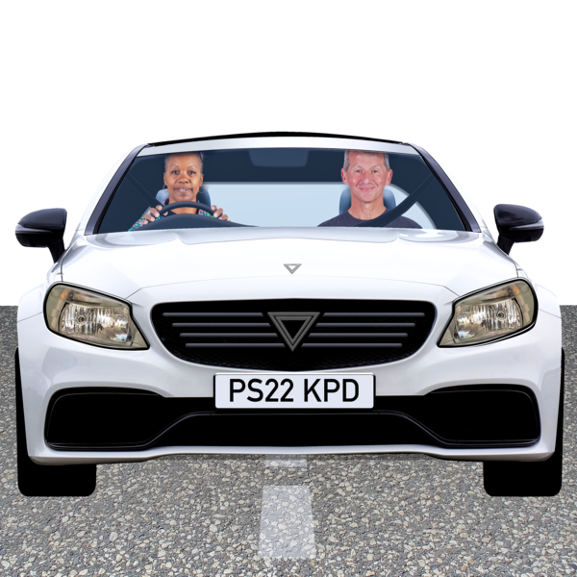
5 minutes
away
Do you think the Government should let ride-hail services like Uber join Total Mobility?

Yes

No

I do not know.

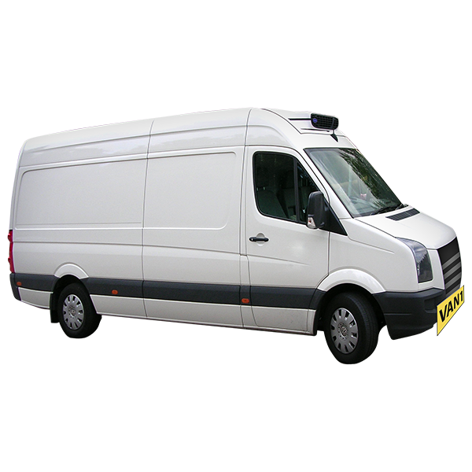
Do you think the Government should let on-demand services like shuttles join Total Mobility?

Yes

No

I do not know.
Do you think the Government should let community transport services join Total Mobility?

Yes

No

I do not know.

Is there anything else you would like to say about this proposal?


You might want to talk about:
the good things about the proposal
the bad things about the proposal
how things could be made safe for people using new providers.

Put your answer in the box below.

Proposal 6: Make public transport cheaper for disabled people across the country.
Tick the box that is right for you.

Do you think the Government should make public transport fares cheaper for people with disabilities?

Yes

No

I do not know.


Is there anything else you would like to say about this proposal?

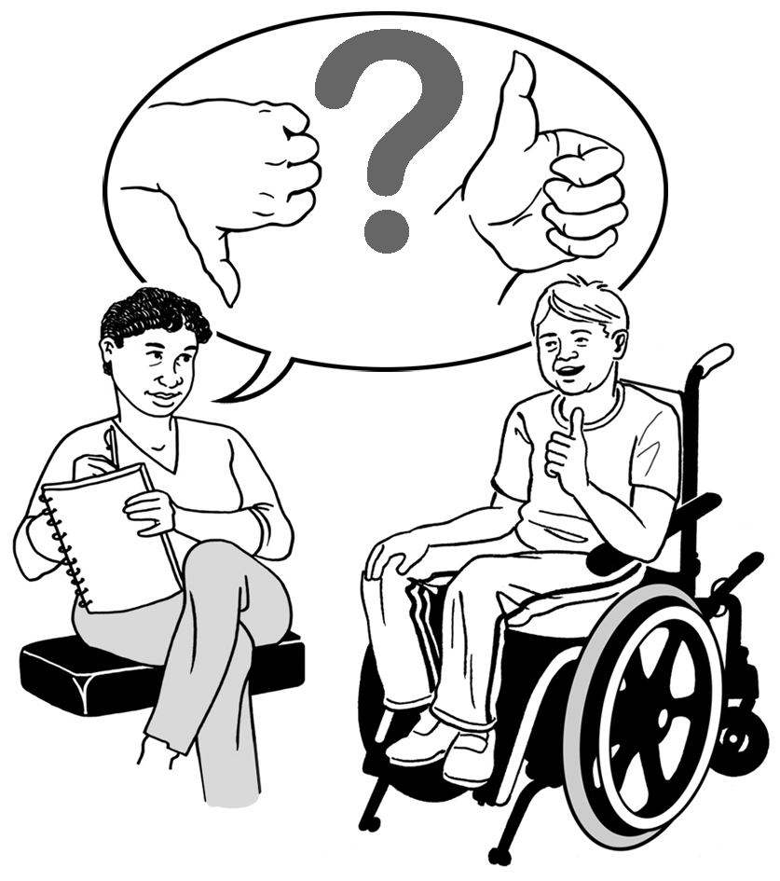
You might want to talk about:
the good things about the proposal
the bad things about the proposal
if this proposal might change how many people use Total Mobility.

Put your answer in the box below.


This information has been written by the Ministry of Transport Te Manatū Waka.

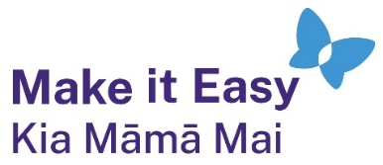
It has been translated into Easy Read by the Make it Easy Kia Māmā Mai service of People First New Zealand Ngā Tāngata Tuatahi.

The ideas in this document are not the ideas of People First New Zealand Ngā Tāngata Tuatahi.

All images used in this Easy Read document are subject to copyright rules and cannot be used without permission.


Make it Easy uses images from:

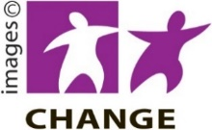
- Photosymbols

- Change Images


- Huriana Kopeke-Te Aho

- SGC Image Works

- T Wood


- Studio Rebeko

- Inga Kramer.

