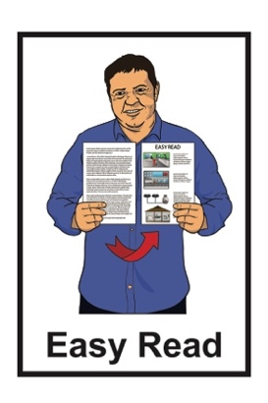


Total Mobility Update

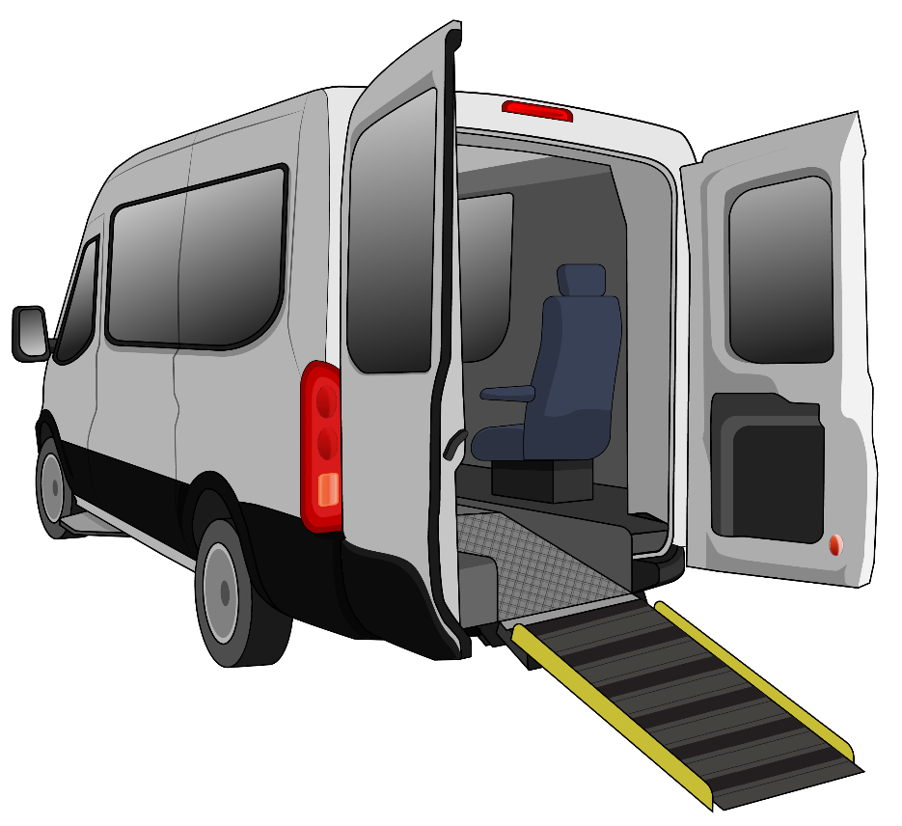

Published: December 2025

About this Easy Read


This Easy Read is from the Ministry of Transport Te Manatū Waka.

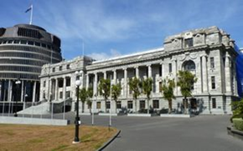
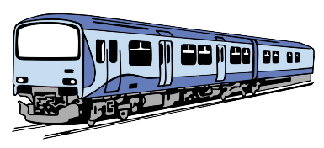
The Ministry of Transport Te Manatū Waka is the part of the Government in charge of the Aotearoa New Zealand transport system.

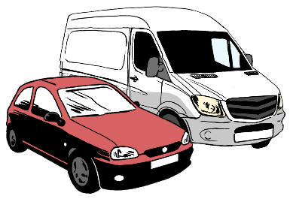
The transport system means anything that moves:
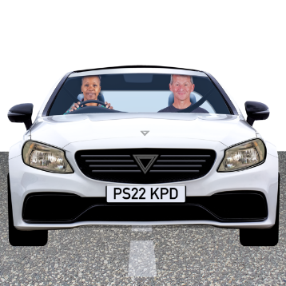
people around the country
things around the country.

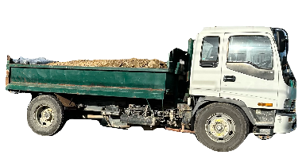
Some parts of the transport system are:
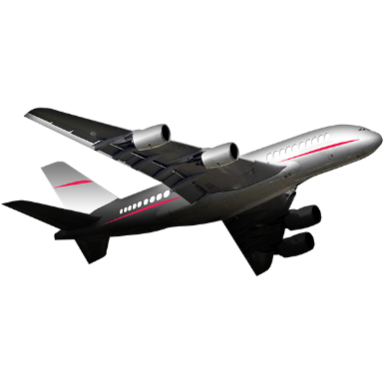
roads
trucks
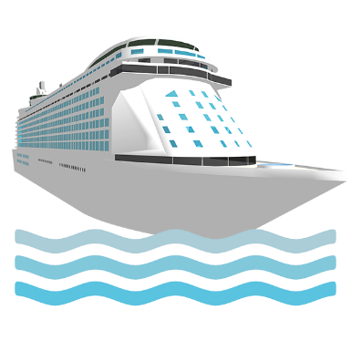
trains
planes
boats.

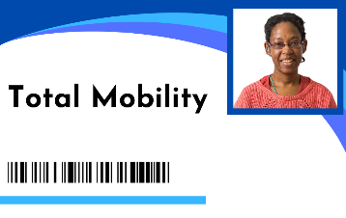
This Easy Read is about changes to the Total Mobility scheme.

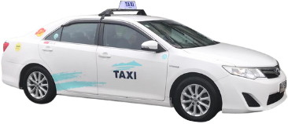
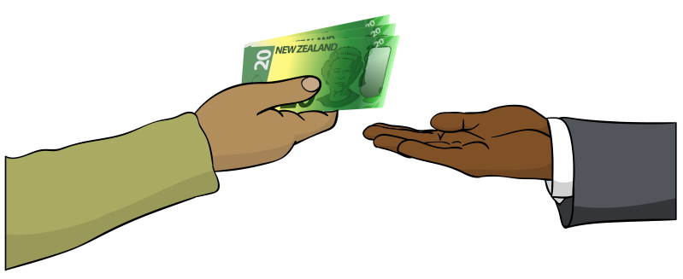
The Total Mobility scheme
supports disabled people to move around by paying part of the cost of taxi trips.

Some of the money for the Total Mobility scheme comes from central government which means the government for all of Aotearoa New Zealand.

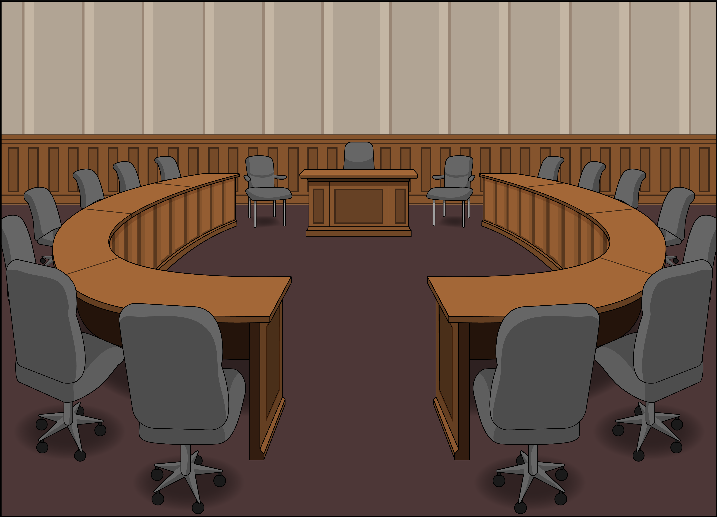
Some of the money for the Total Mobility scheme comes from local government like public transport authorities.

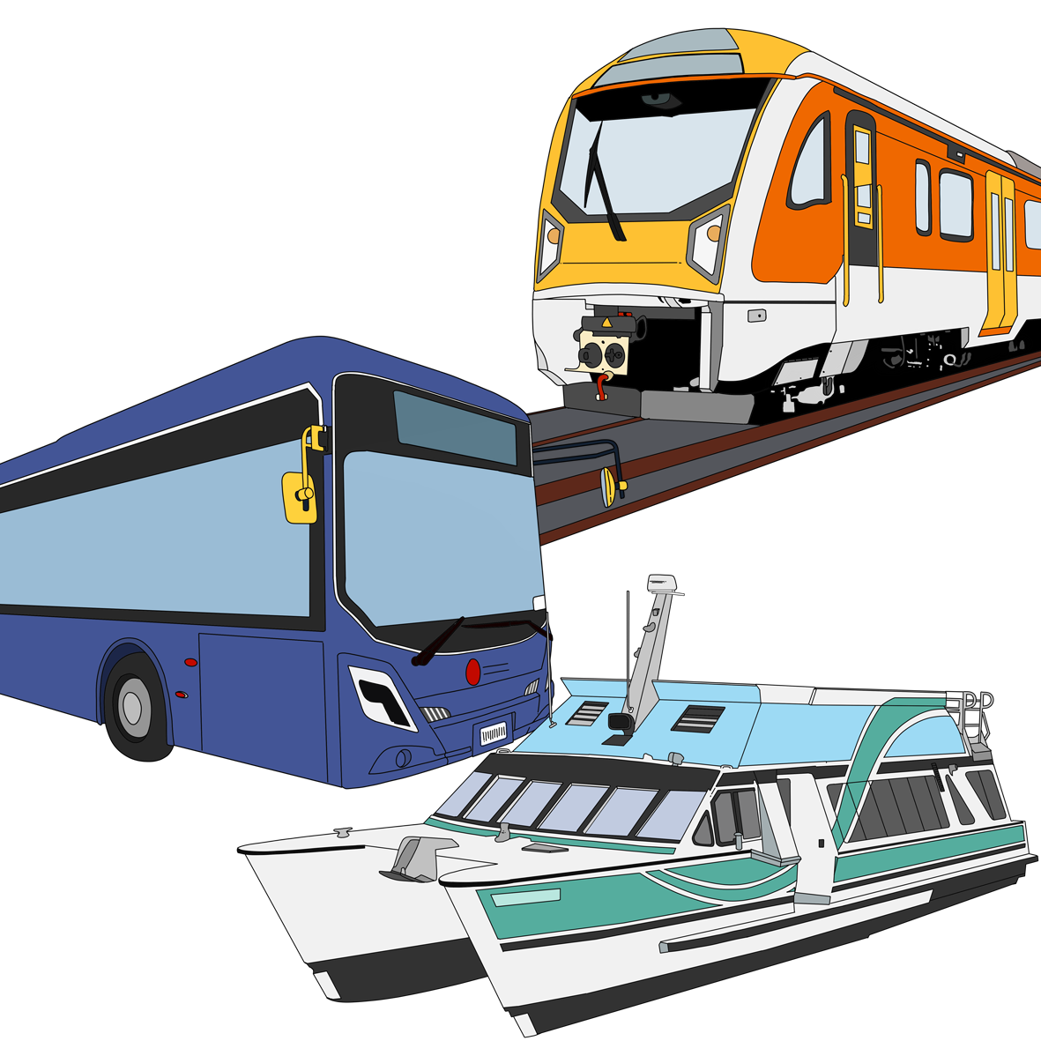
Public transport authorities are in charge of public transport in their
part of Aotearoa New Zealand.

For example:

Auckland Transport is the public transport authority in Auckland
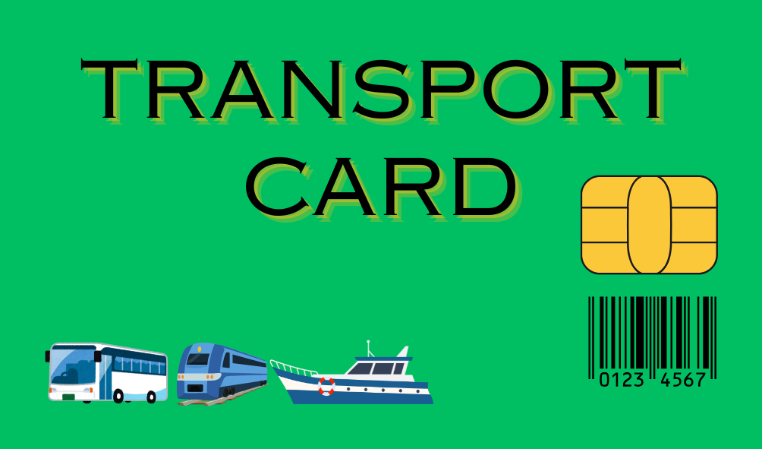
Greater Wellington Regional Council is the public transport authority in Wellington.

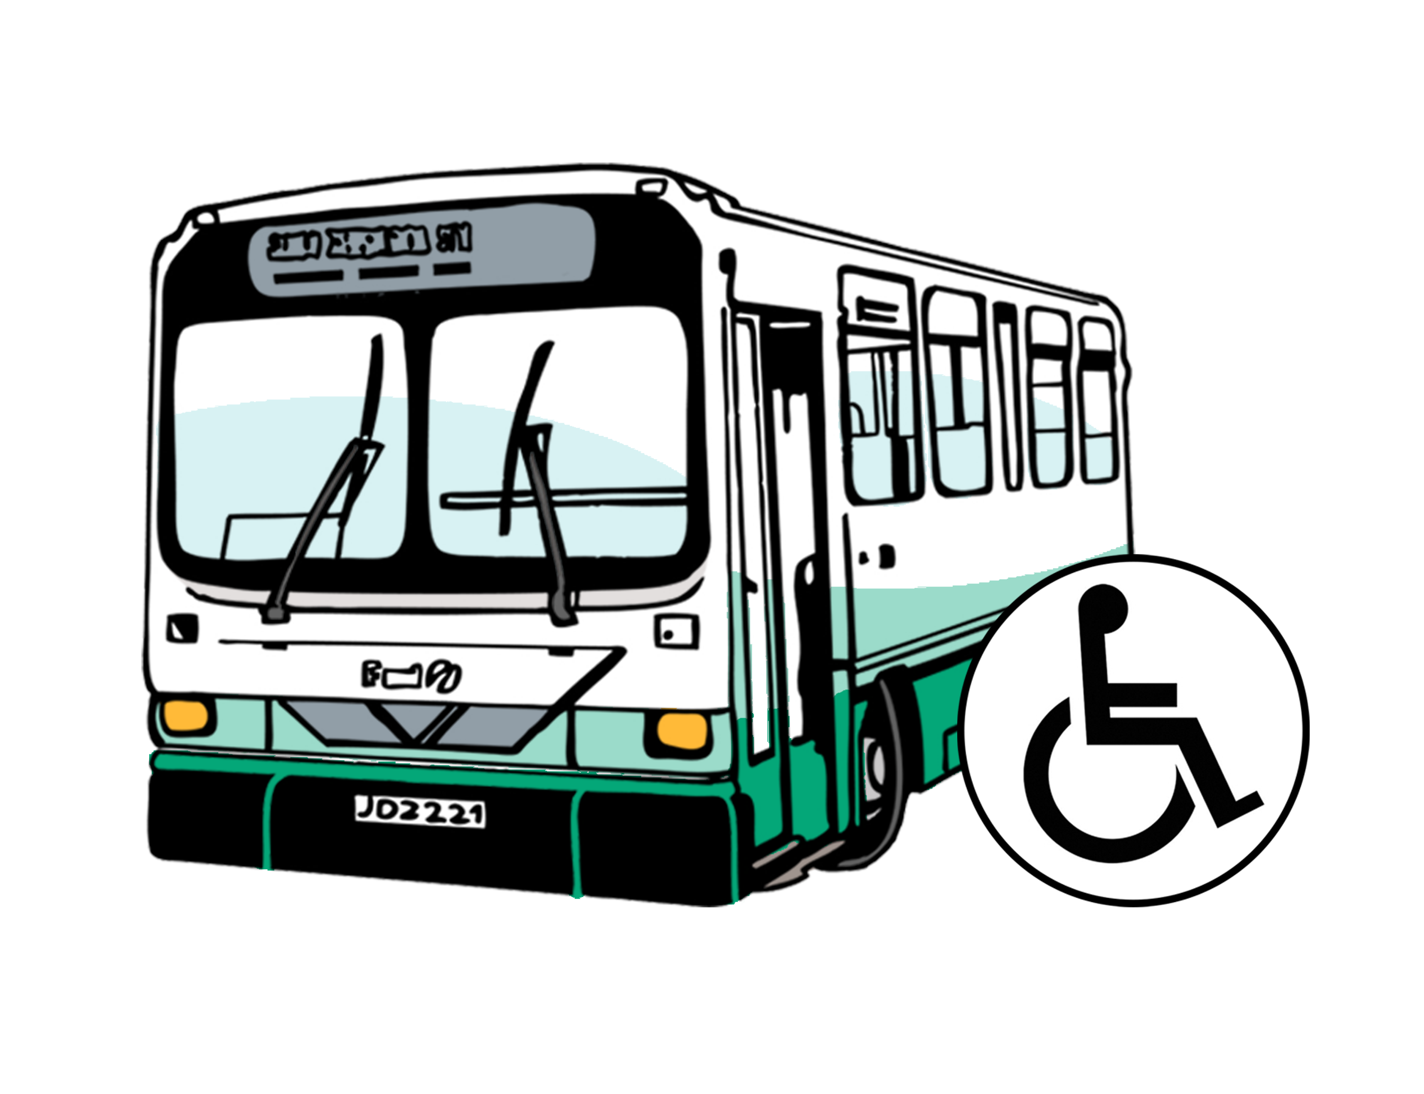
Disabled people can use Total Mobility if they cannot use public transport on their own.

Public transport means:
buses
trains
ferries.

Changes to the Total Mobility scheme

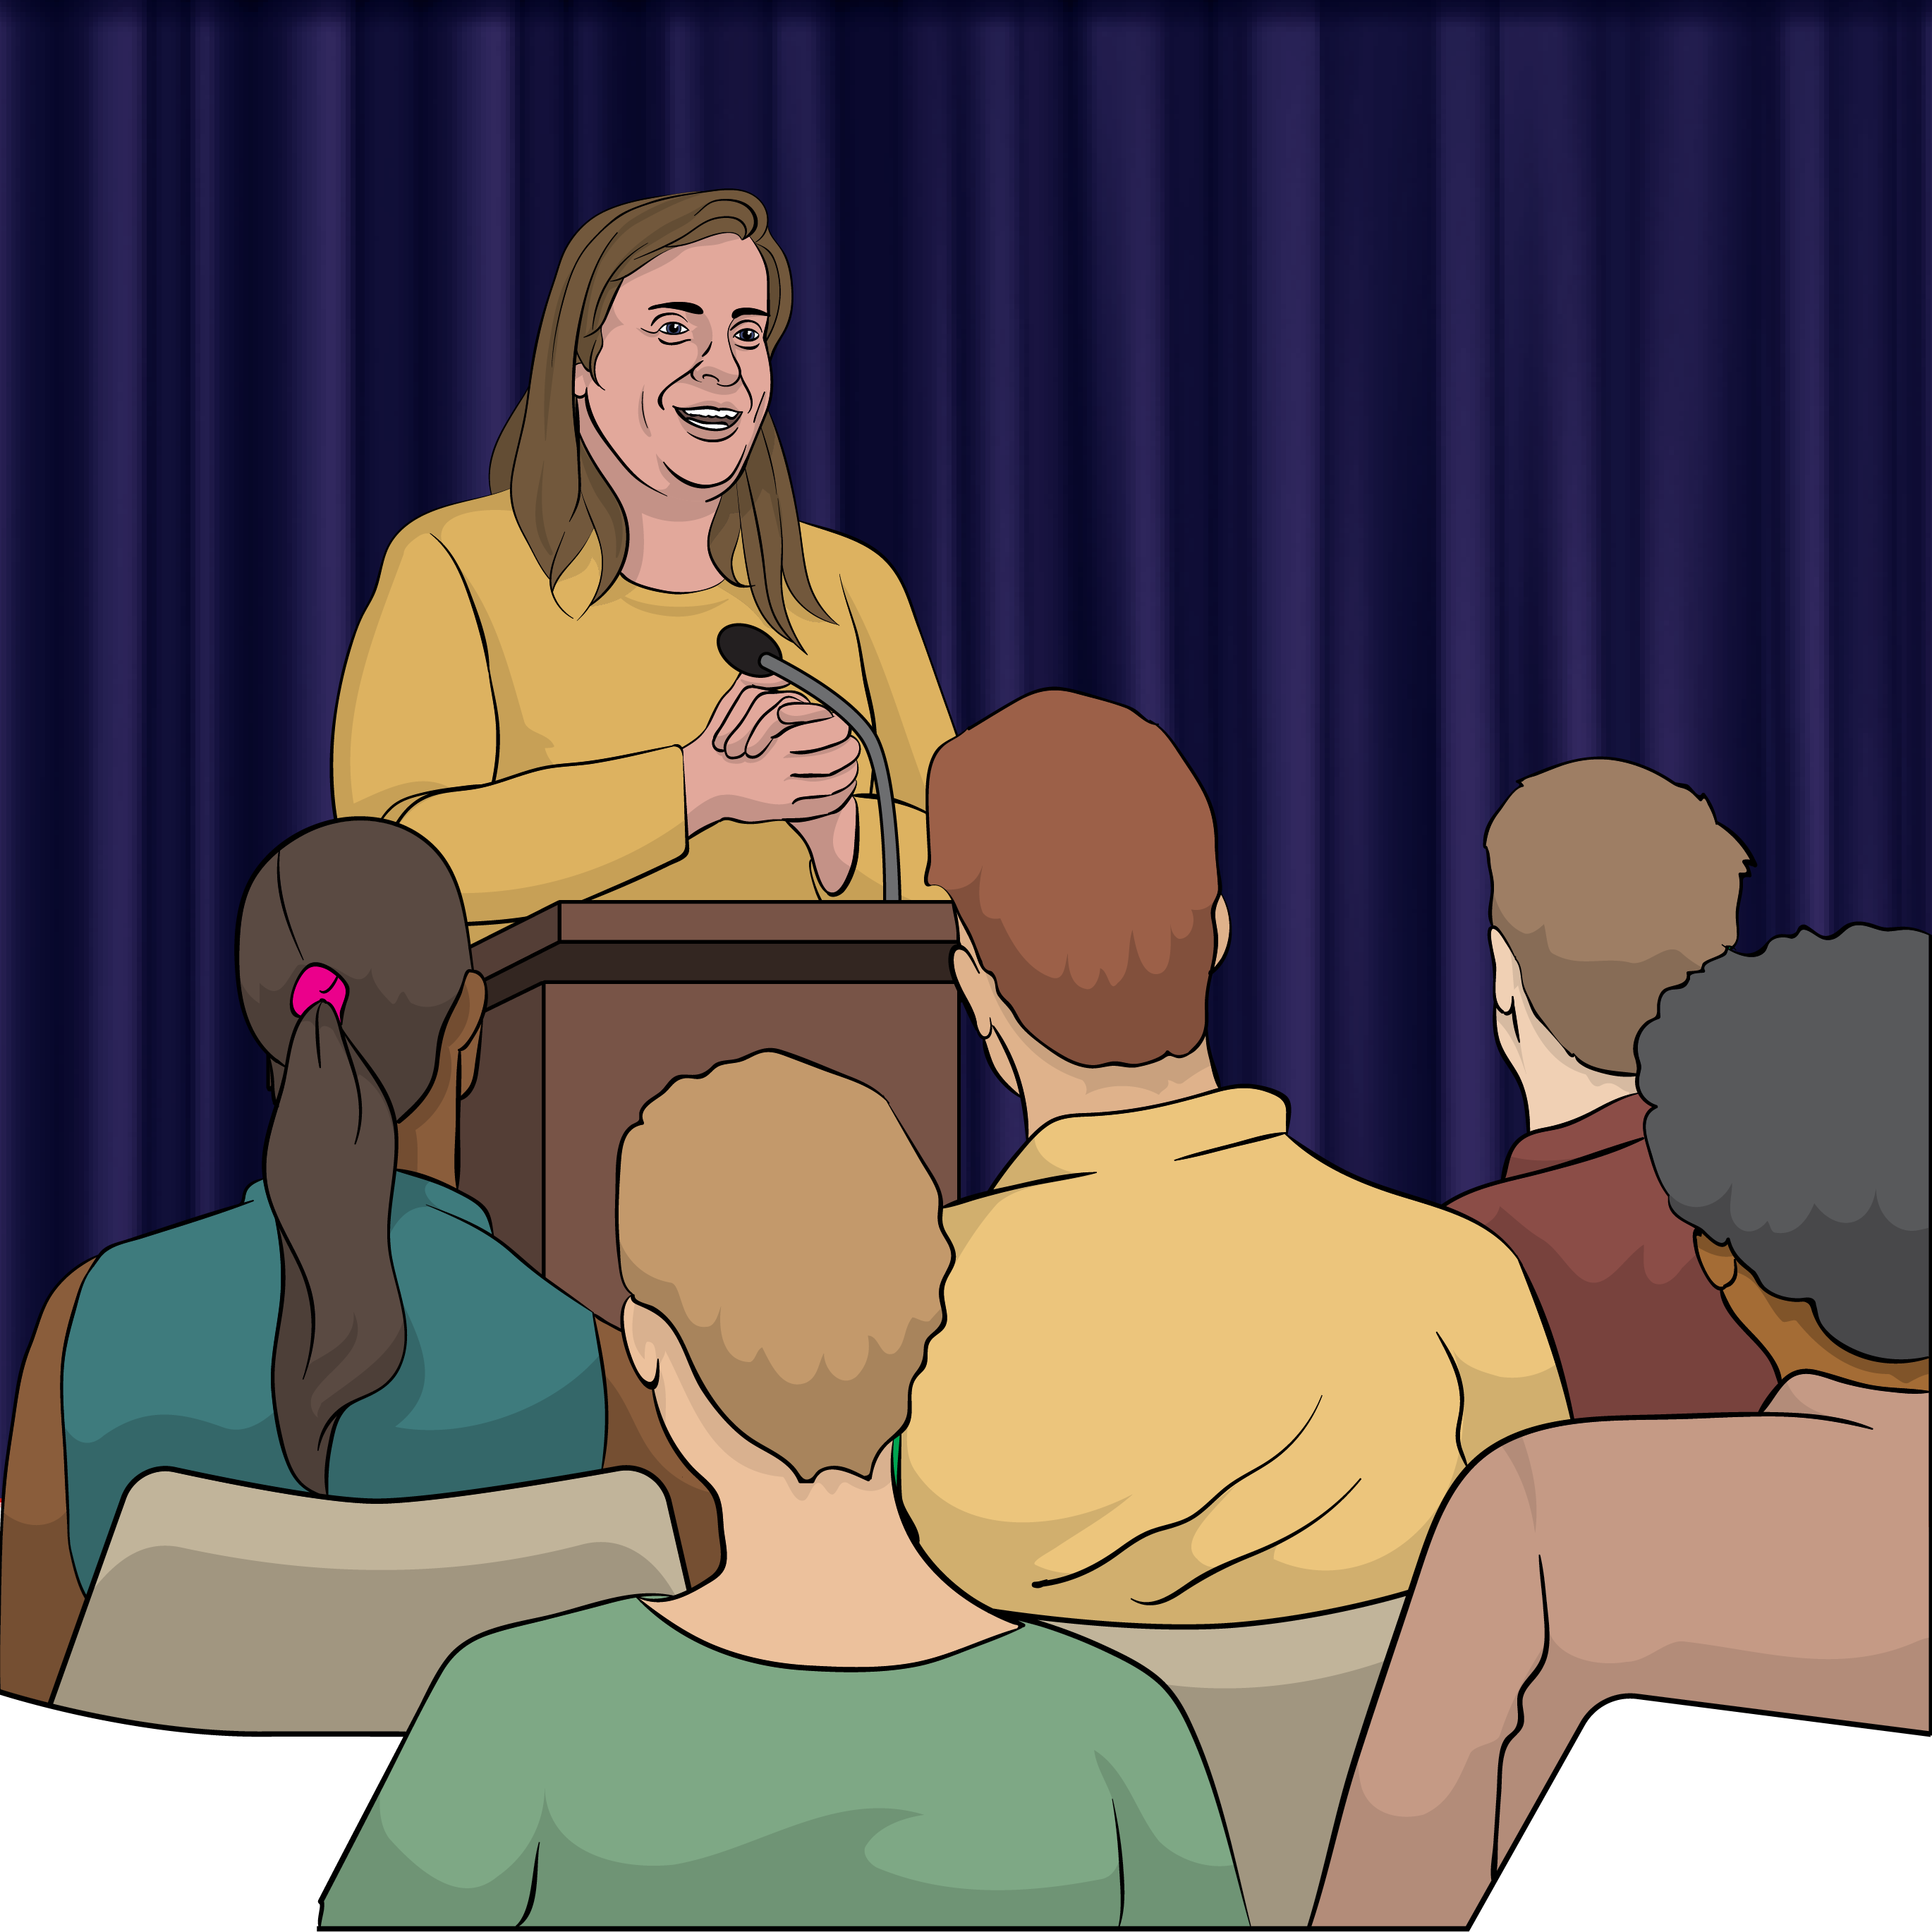
The Government has said it is going to change the Total Mobility scheme.


The changes will mean the:
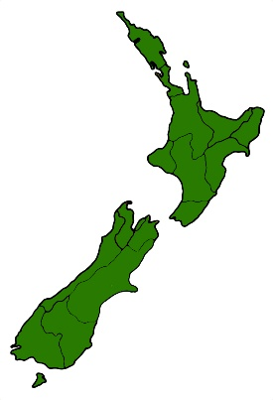
Government can keep paying for the Total Mobility scheme in the future
Total Mobility scheme will not have to work differently in each part of Aotearoa New Zealand.


The Government hopes these changes will not be too hard for Total Mobility users.

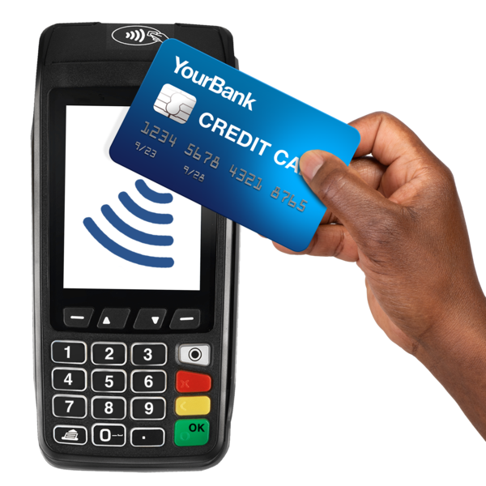
At the moment for every 1 dollar a taxi trip costs the:
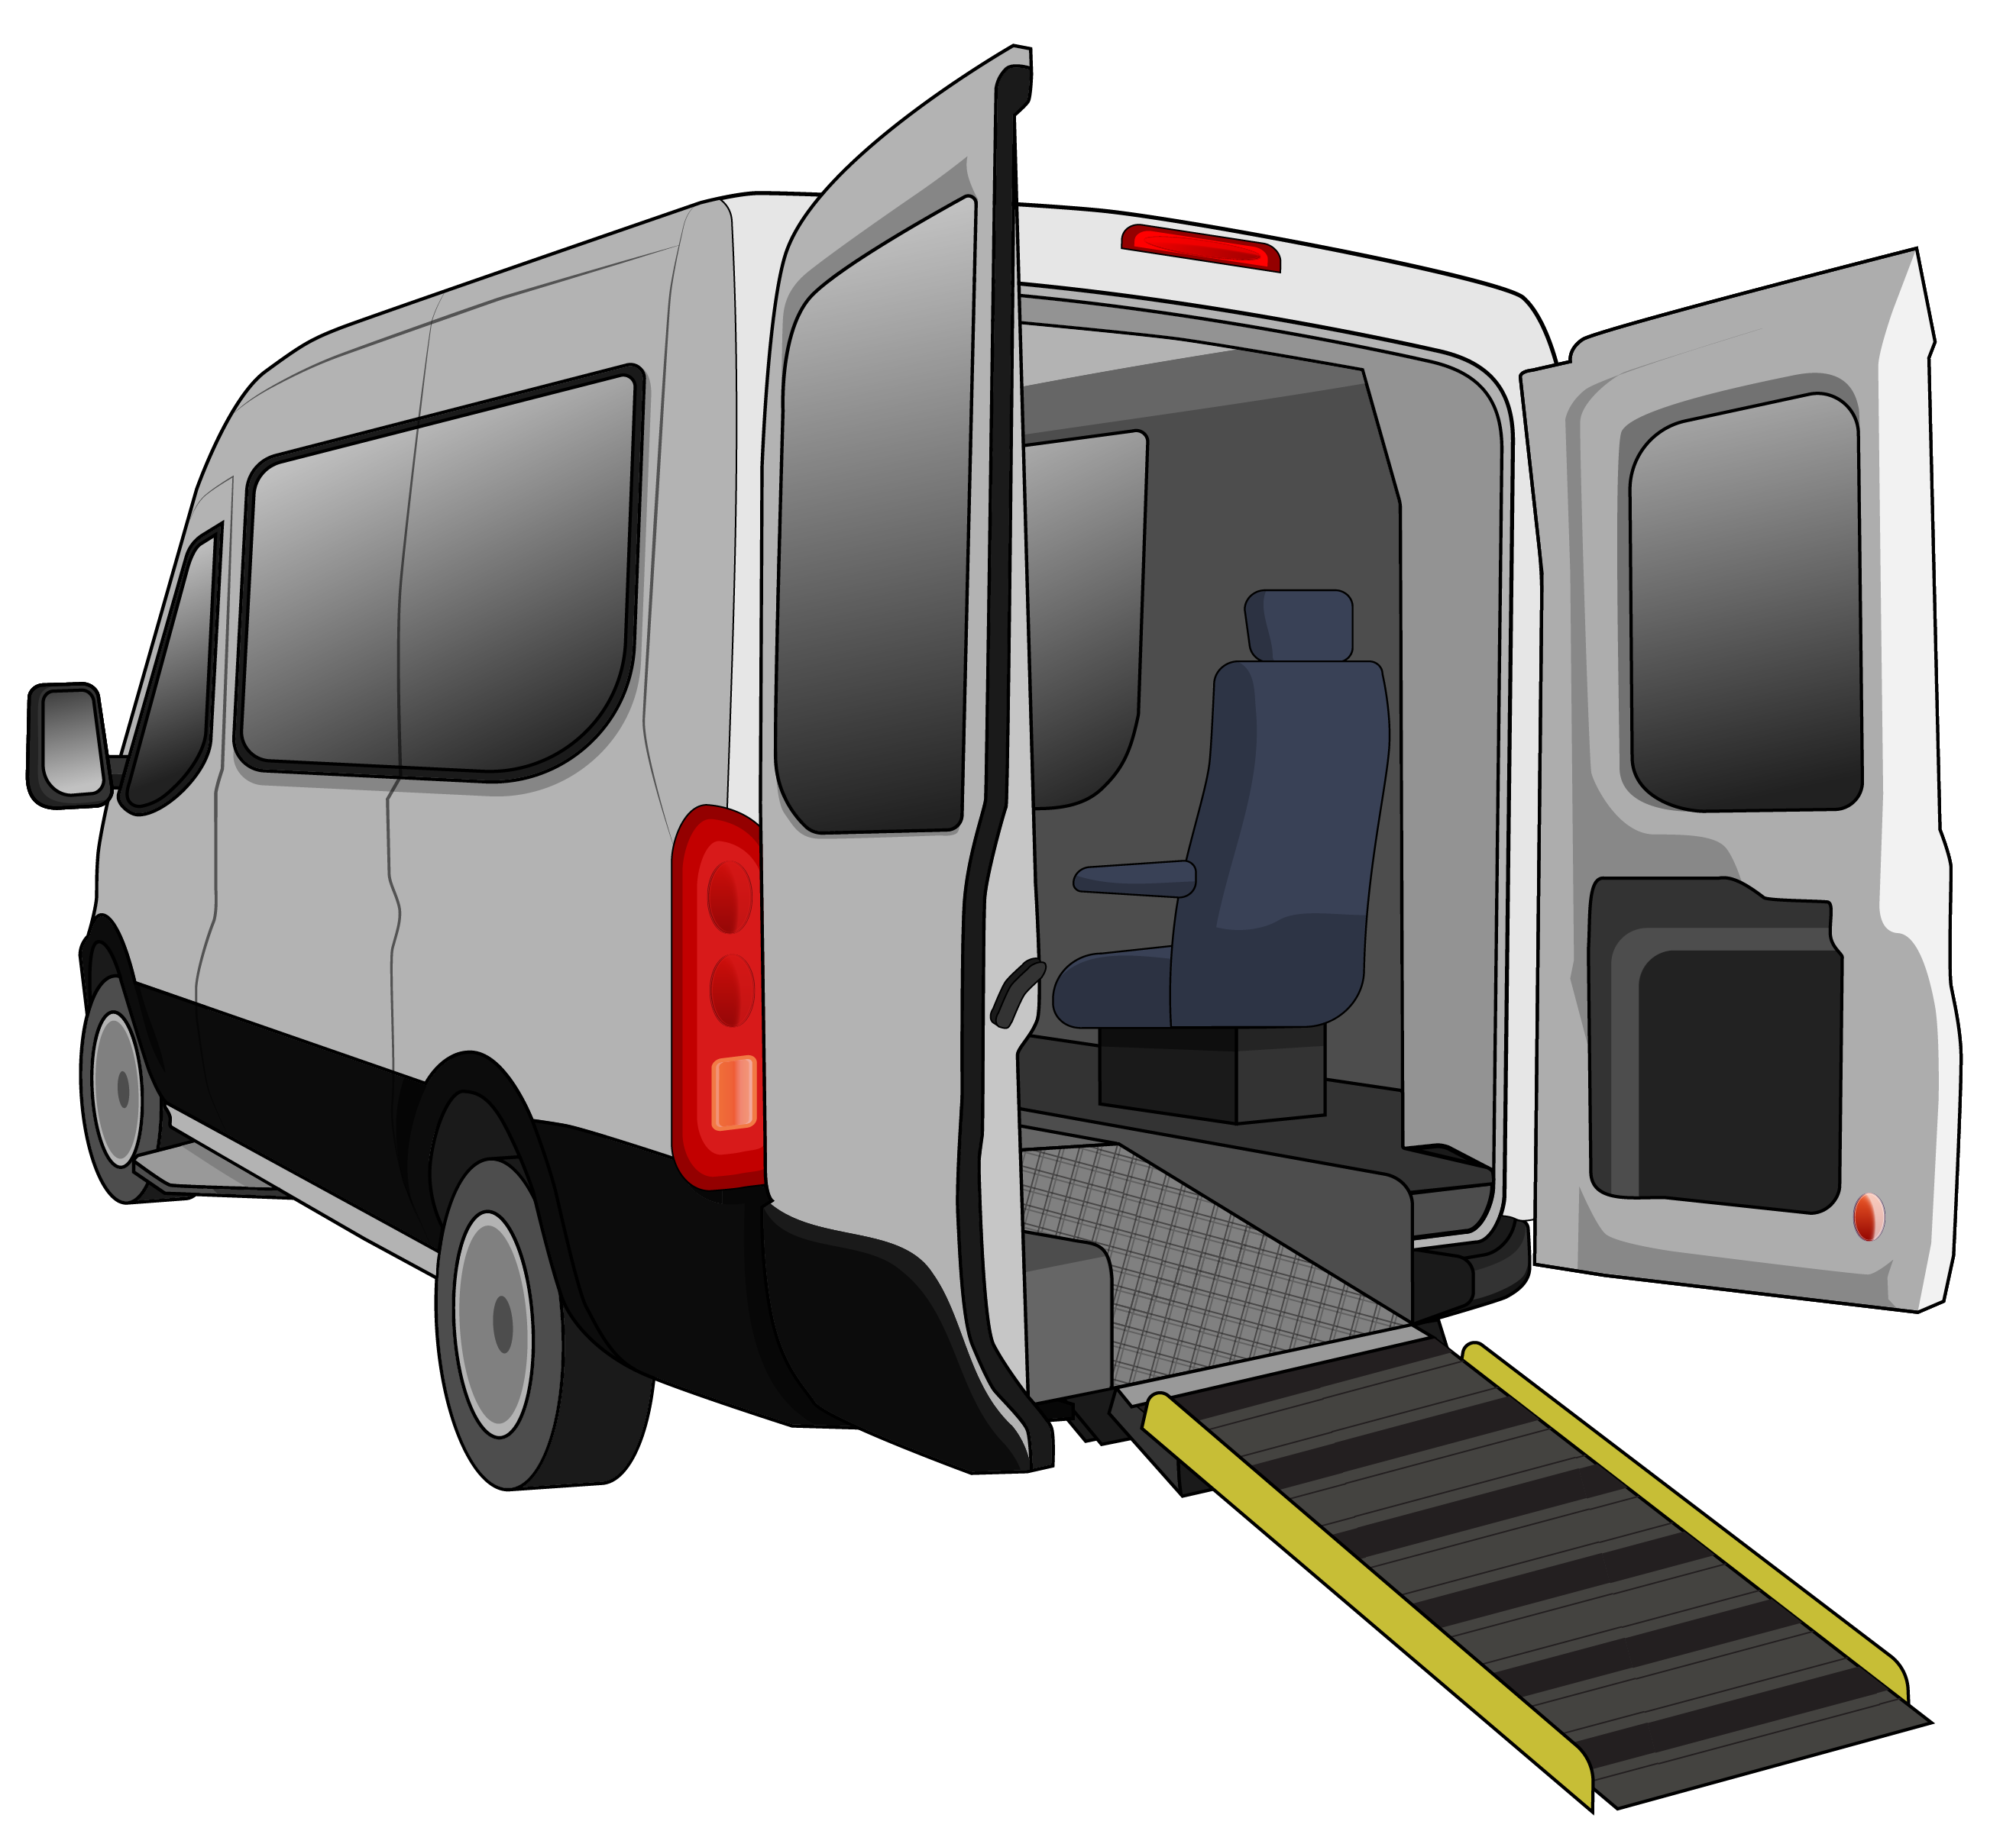
Government pays
75 cents
Total Mobility user pays
25 cents.
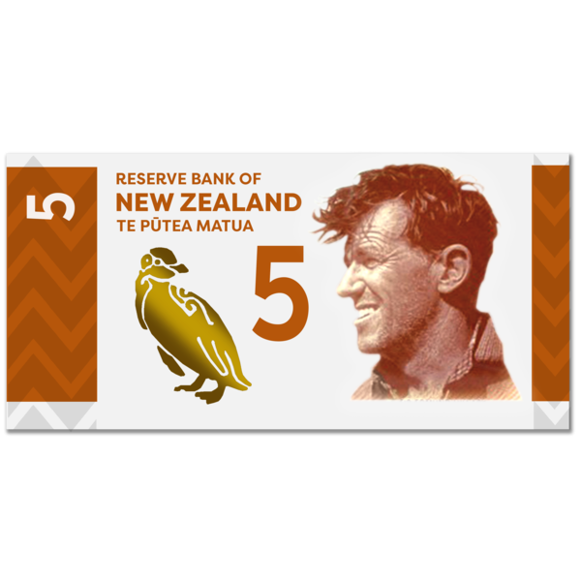
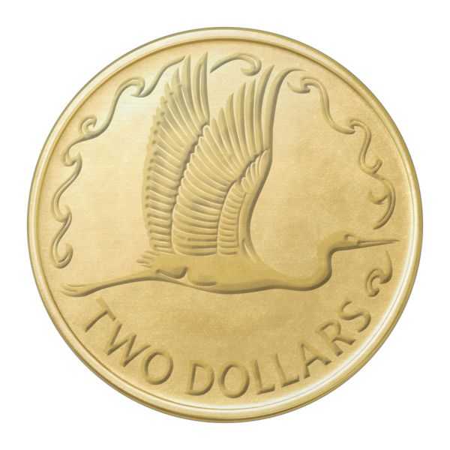
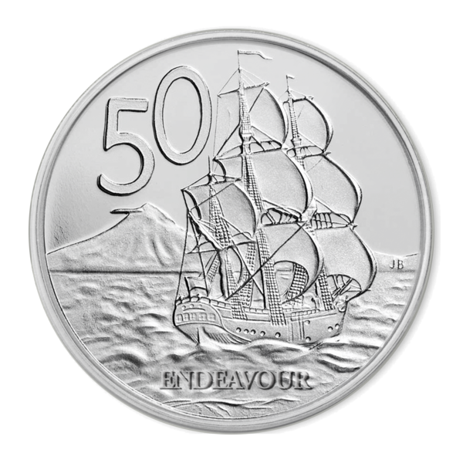

For example for a taxi trip that costs 10 dollars the:
Government would pay
7 dollars and 50 cents
Total Mobility user would pay
2 dollars and 50 cents.
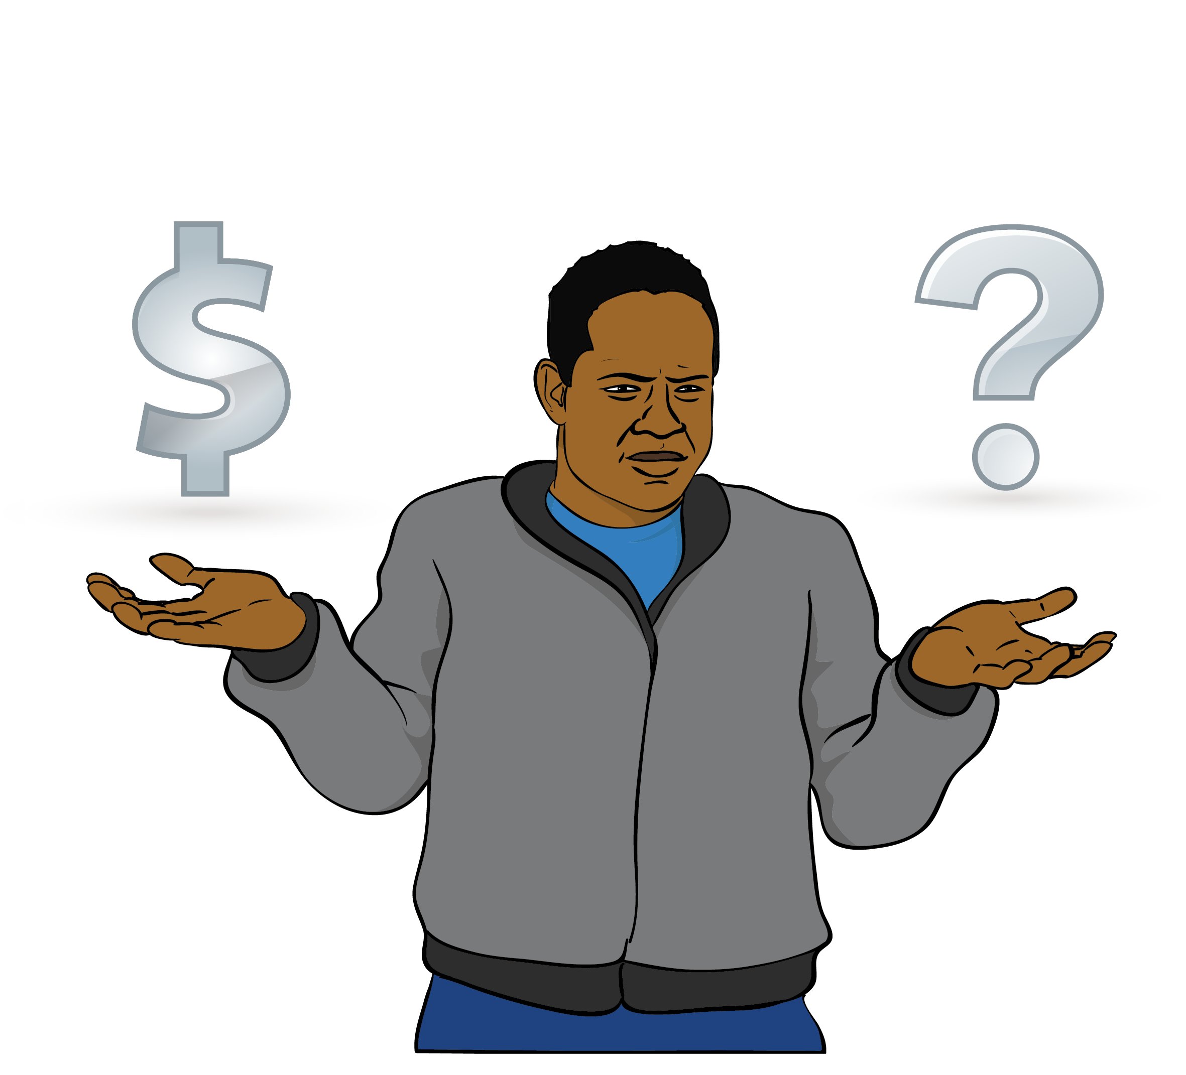

The Government has decided to pay less for each taxi trip.

This means for every 1 dollar a taxi trip costs the:
Government will pay
65 cents
Total Mobility user will pay
35 cents.
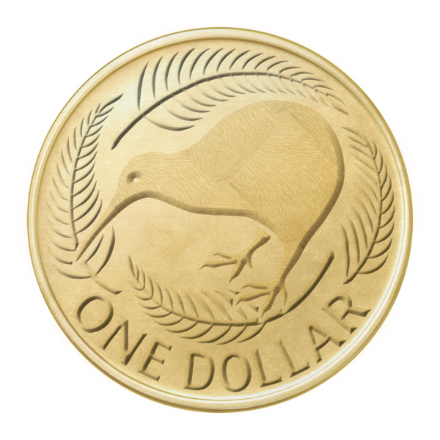

For example for a taxi trip that costs 10 dollars the:
Government would pay
6 dollars and 50 cents
Total Mobility user would pay 3 dollars and 50 cents.


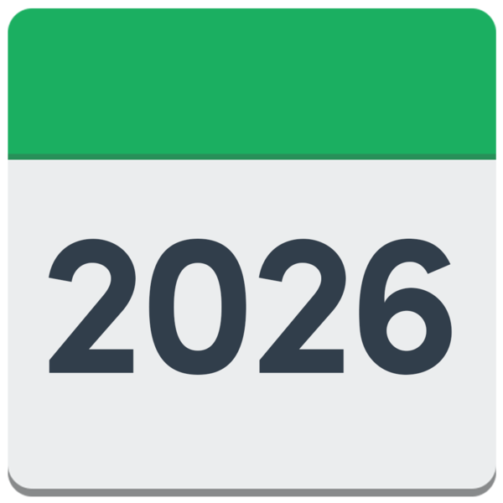
These changes will start on 1 July 2026.

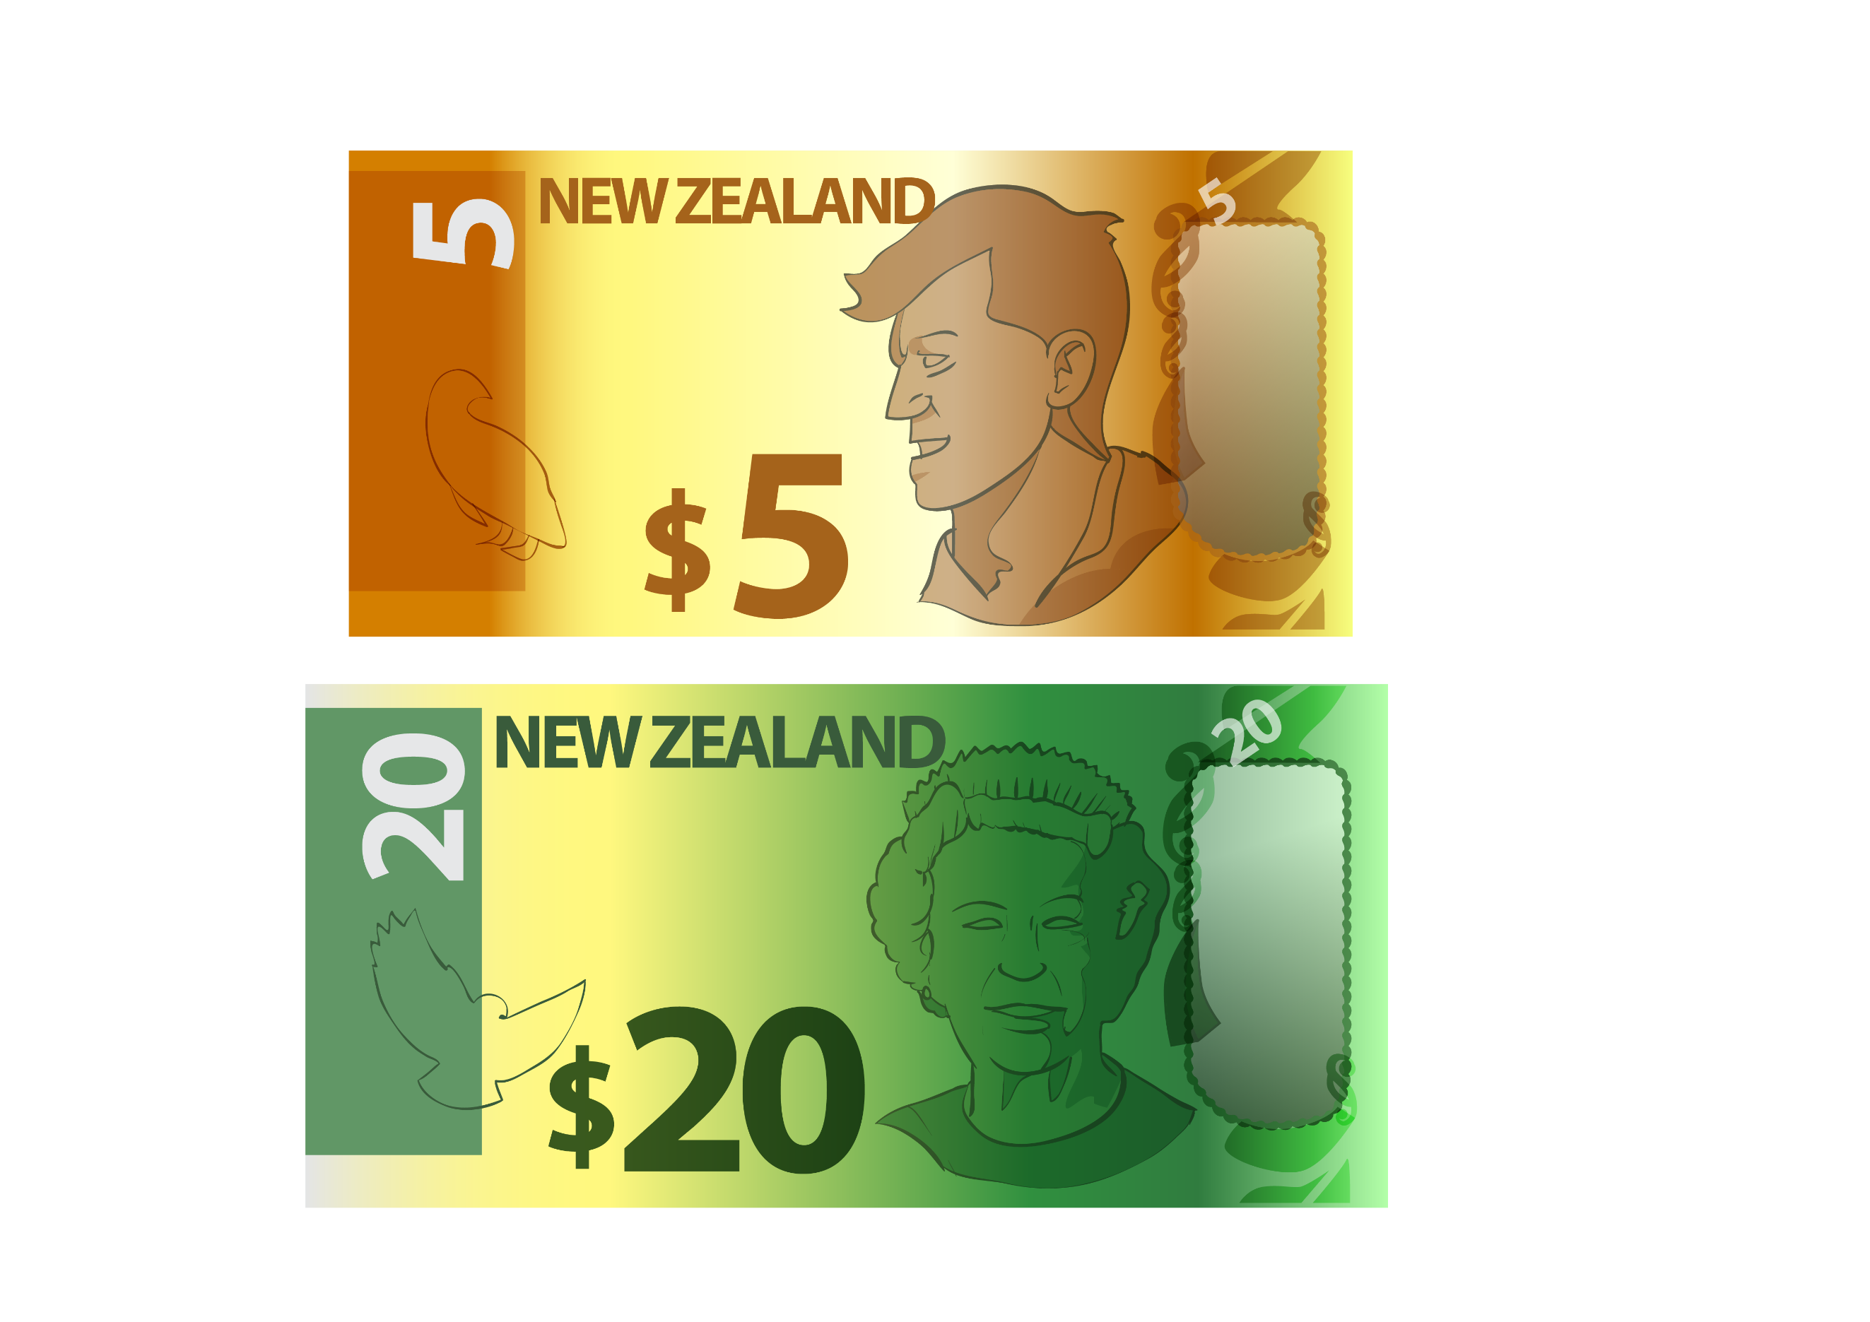
The Total Mobility scheme also has a fare cap.

A fare cap is the highest amount of money the Total Mobility scheme
will pay part of for each trip.

For example if the fare cap is
25 dollars the Government will pay part of every dollar for the first 25 dollars.

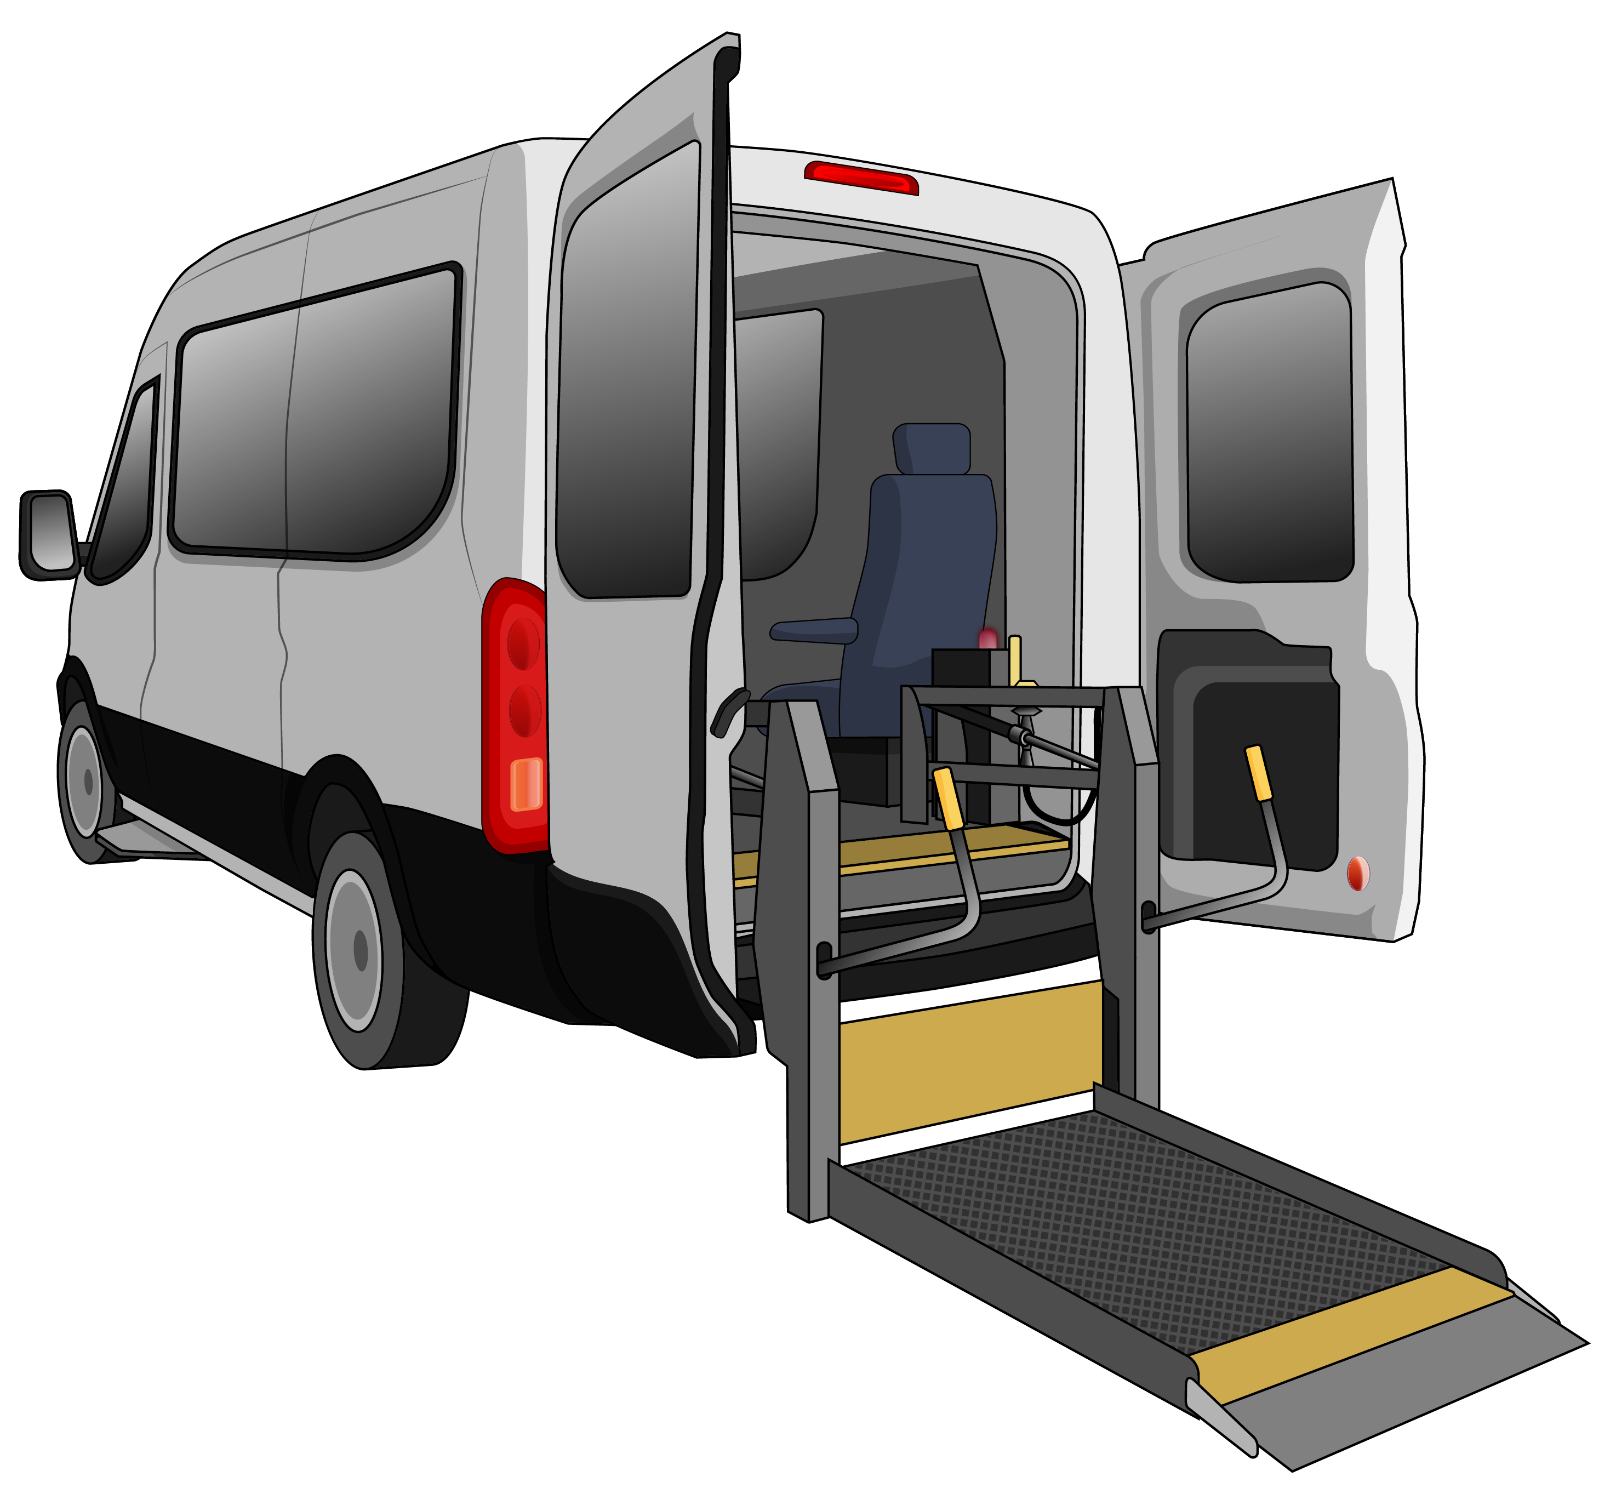
If the trip costs more than
25 dollars the Total Mobility user will have to pay the full cost of every dollar over 25 dollars.

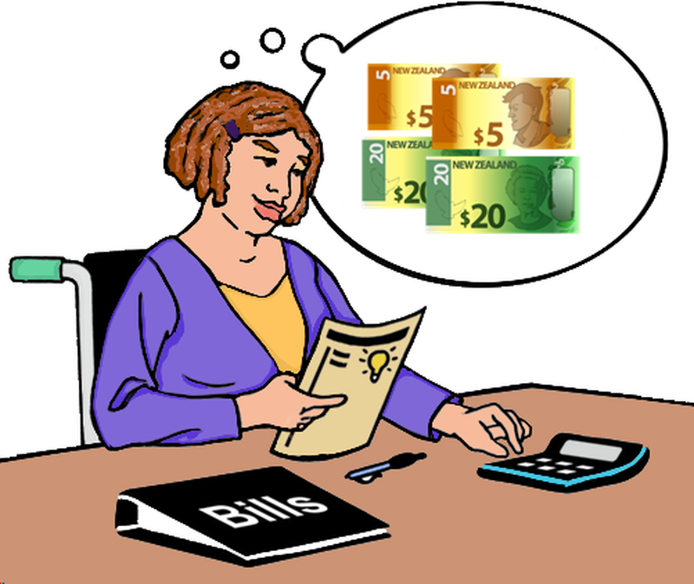
Each part of Aotearoa New Zealand has a different fare cap.

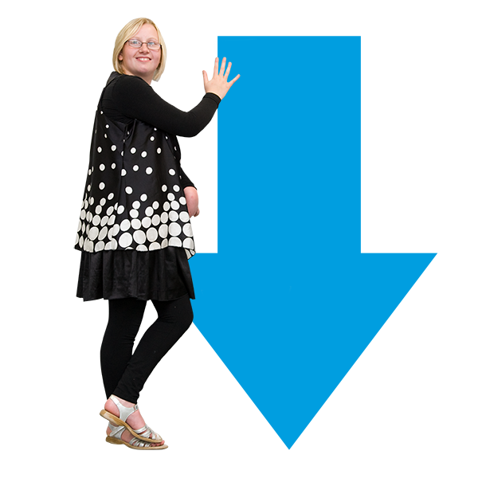
The Government wants to make all of the fare caps lower.


The Government is going to give public transport authorities some more money so they can keep paying for the Total Mobility scheme.

The extra money for public transport authorities will come from money the Government already spends on the Total Mobility scheme.

Public consultation


The Government has some other ideas about how to make the Total Mobility scheme better.

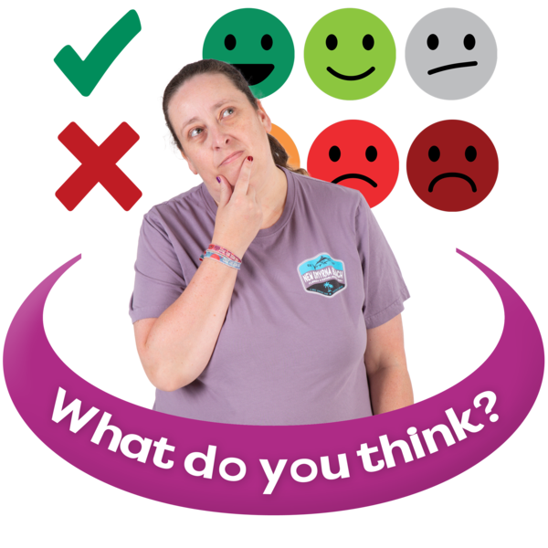
It is doing a public consultation on these ideas.

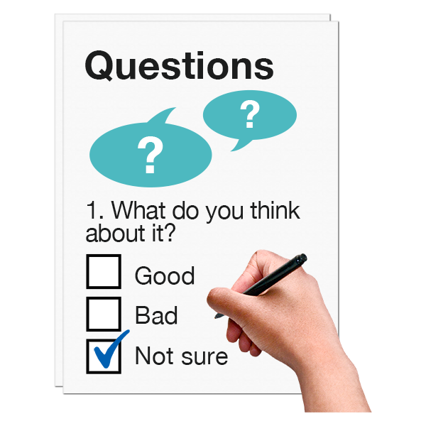
A public consultation is when the Government asks people what they think about an idea.

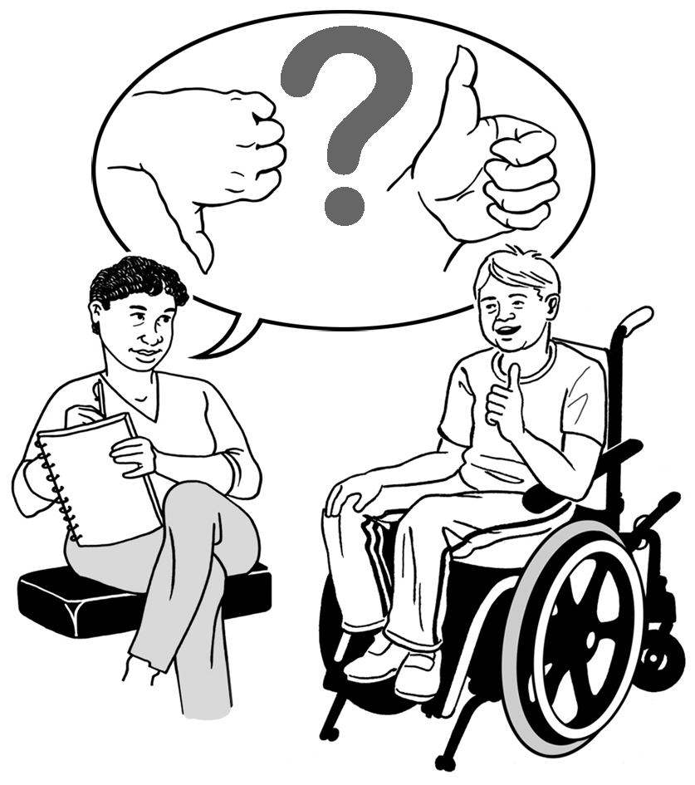
You can have your say as part of the public consultation now.


You need to have your say before
22 March 2026.

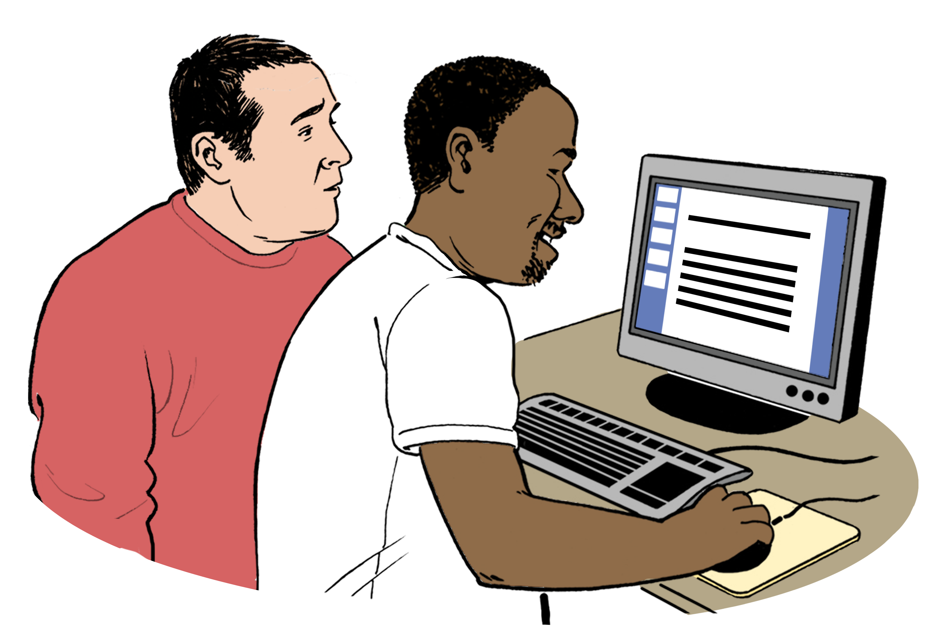
You can have your say at:

https://tinyurl.com/yehkjmnw
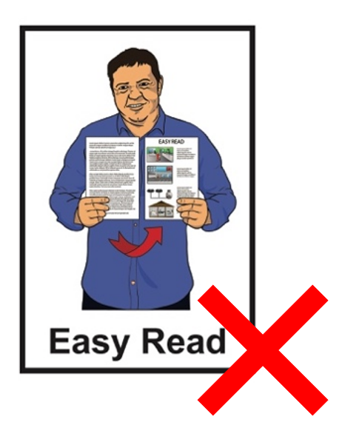

This website is not in Easy Read.


This link also has more information about the public consultation.

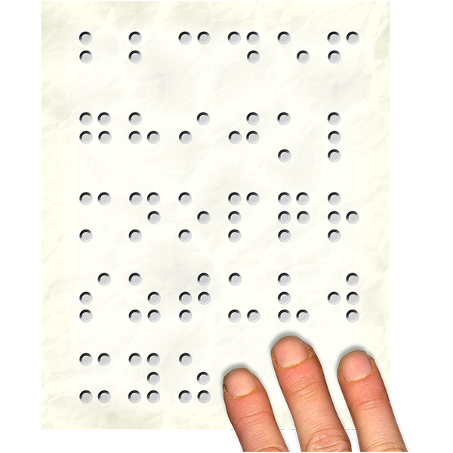
There will be information about the public consultation in:
Easy Read
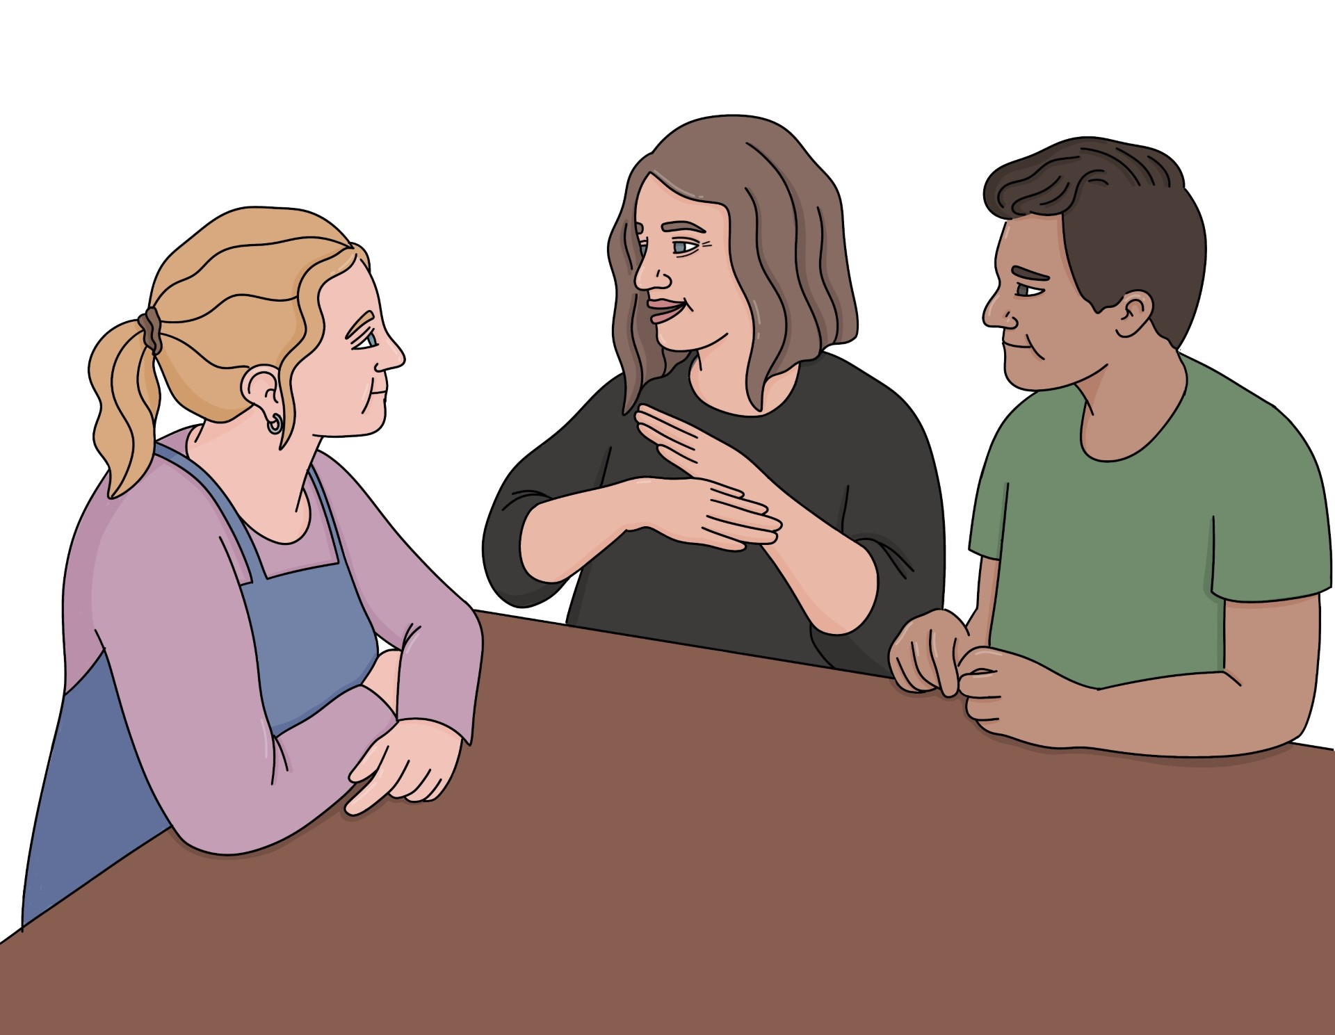
Braille
large print
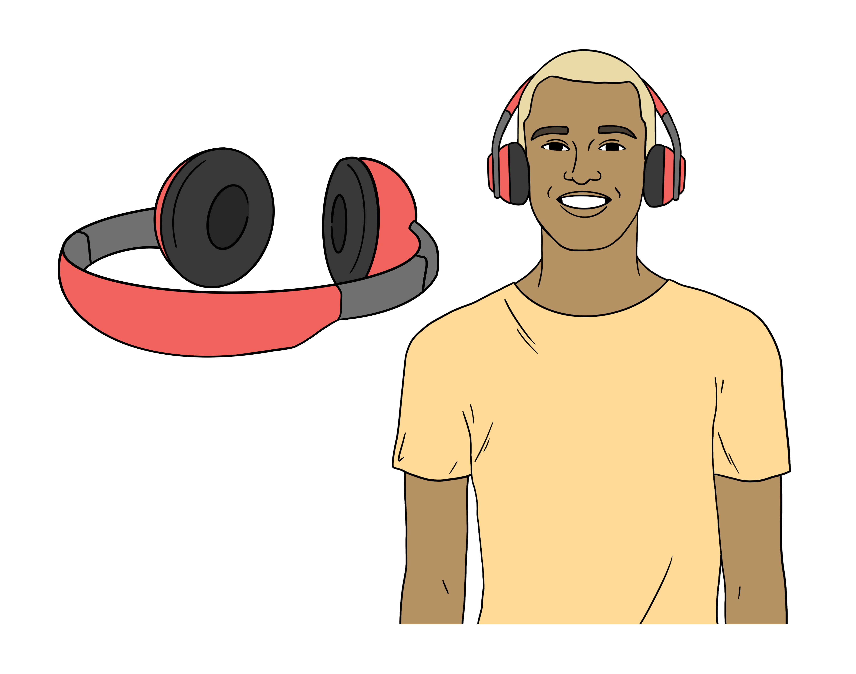
New Zealand Sign Language
audio.


You can read what the Transport Minister had to say about the changes to the Total Mobility scheme at:

https://tinyurl.com/5y6rkd5w
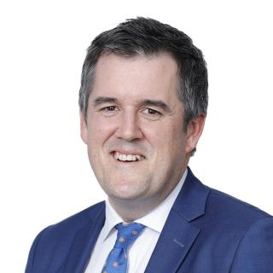

The Transport Minister is the person in the Government in charge of the transport system.

What the Transport Minister said is not in Easy Read.


This information has been written by the Ministry of Transport Te Manatū Waka.

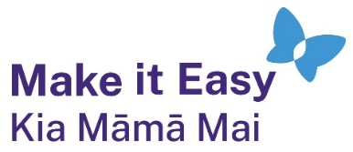
It has been translated into Easy Read by the Make it Easy Kia Māmā Mai service of People First New Zealand Ngā Tāngata Tuatahi.

The ideas in this document are not the ideas of People First New Zealand Ngā Tāngata Tuatahi.

All images used in this Easy Read document are subject to copyright rules and cannot be used without permission.


Make it Easy uses images from:

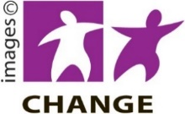
- Photosymbols

- Change Images

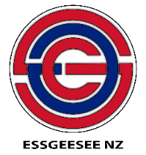
- Huriana Kopeke-Te Aho

- SGC Image Works

- T Wood


- Studio Rebeko

- Inga Kramer.

